 | 2018 | COLLINGWOOD CASE STUDY:  DETAILED ECOLOGICAL REPORT
Prepared by Richard Thackway

Key findings
John Kane’s cattle breeding property “Collingwood” of 242 ha is located south west of the Grampians in the western district of Victoria. It is situated on the Dundas Tablelands and at the state and national levels the property is located within the Victorian Midlands IBRA region. Across most of the Dundas Tablelands the native woodland vegetation was historically heavily cleared and transformed for intensive agriculture, including grazing and some cropping.
Before John commenced managing Collingwood in 1996, his uncles managed what was to become “Collingwood” as two separate and adjacent farms. A detailed chronology of production systems applying to “Collingwood” is presented in Attachment A.
John has increased the storage of winter rainfall in the soil over the winter months so that pasture plants can access it during the summer. Fundamental to storing winter rain in the soil was learning how to improve soil hydrology. John found that the soil had a hardpan at a depth of about 200mm, caused by years of ploughing with a mouldboard plough.
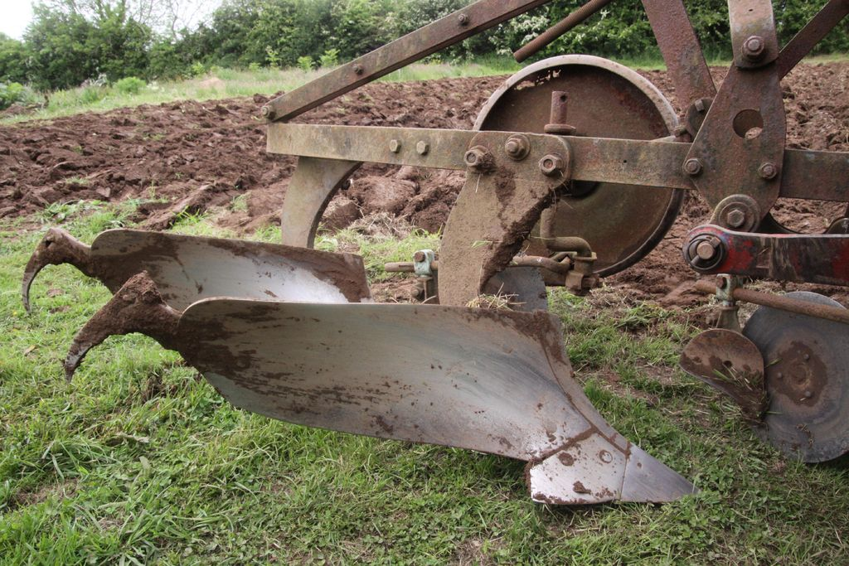
Mouldboard plough
When John took up managing Collingwood, he started with the sheep and cattle his uncle was breeding. In 2000 John decided that he would get rid of the sheep and concentrate on improving the quality of his cattle herd, yards and fencing because the infrastructure for both sheep and cattle was inadequate. Initially he purchased more expensive bulls with proven genetics to turn off calves at a higher weaning weight and better structure. However, he decided that feeding cattle on degraded pastures was not the best strategy so undertook a vigorous pasture improvement program realising that the starting point must be improving soil fertility.
The basis of his reasoning was if you have healthy soil you can grow healthy plants and the cattle will eat the healthy pastures. It then follows: healthy soil = healthy plants = healthy stock = healthy humans. It all starts with the health of the soil.

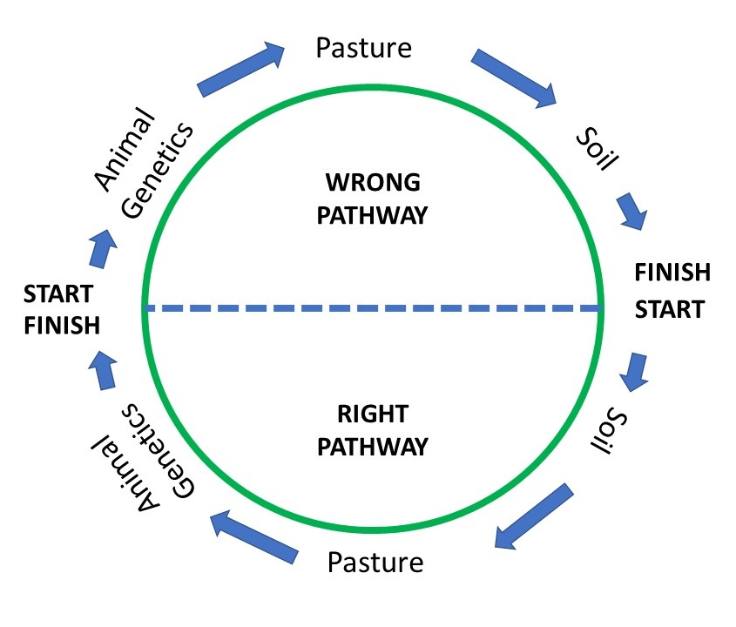

To solve the hard pan issue in his soil, and to improve productivity John’s solution was threefold; mechanical, chemical and biological.
1) Using a heavy duty soil aerator towed by a 4wd tractor was used to cut through the hardpan.
2) Adding lime to modify the pH to improve pasture growth, and
3) Encouraging populations of European dug beetle, Bubas bison which improves soil aeration, increases water infiltration into soil, which reduces run-off and increases root penetration.
In 1998-2000 John commenced a regular program to establish deep rooted perennial grasses including phalaris and cooksfoot using direct drill. Around this time he started a journey toward understanding and initiating biological farming and took intensive courses in beef breeding, pasture management and water management.
During this period the two smaller family farms were aggregated to create one 600 acre farm and John initiated trials of rotational grazing.
Now John does not plough the soil because of the high risk of soil erosion, instead uses direct drilling to seed the different grasses. He knows that to prevent soil erosion he must maintain healthy soil and healthy plants and looks to maintain dense and deep roots and high ground cover levels to prevent the soil from drying, cracking and opening-up.
Collingwood is divided into 5 paddocks rotationally grazed with reticulated water toughs available for stock in each paddock. Animal movement is based on visual assessment of food availability and animals indicate to John when they are ready to move. (70 cows and calves over 20-30 acres or 8-12 ha).
John cuts high-quality pasture hay for his farm and uses this as an important management strategy coinciding with the onset of wetter months. He starts feeding out hay from late February and continues to mid-August, with some breaks in Autumn as sometimes with the changing of the seasons there is a good balance of dry and green feed on offer.

 | Production system
Phase 1: 1996-1997 | Commenced managing 300 acres conventional grazing with crossbred sheep and angus cattle. Attended Neil Kinsey seminar in 1996 and decided to change his farming methods. Commenced regular soil tests
Phase 2: 1998-2000 | Commenced a regular program to establish deep rooted perennial grasses like phalaris and cooksfoot using direct drill. Started on journey of implementing biological farming. Started courses in beef breeding, pasture management and water management. Aggregated two family farms to create one 600 acre farm. Initiated trials of rotational grazing
Phase 3: 2001-2008 | Installed 120,000 litre capacity tanks on the highest part of the farm to store dam water and then reticulate to stock troughs. Implemented a comprehensive rotational grazing program as now had water in every paddock.
Phase 4: 2009-2018 | Farm managed fully regenerative. John’s experience enabled him to become a founding member of district’s “Soil Health Group”. Continued to replace and improve infrastructure associated with handling stock, watering stock and electric fencing.

Collingwood in ecological context
“Collingwood” comprises undulating hills 90 to 150 m, above sea level, and a valley that drains to the Wannon River; which is a tributary of the Glenelg River.
The Dundas Tableland is a dissected duricrust plateau comprising a thin layer of marine Tertiary sediments overlaying a Palaeozoic palaeoplain (VEAC 2010). The geology of the Tablelands is variable, ranging from sedimentary beds, metamorphosed sediments, granites, trachyte, rhyolite and volcanics (Agriculture Victoria 1996 – 2019a).
Yellow texture contrast soils dominate in the mid and upper slopes and on the tabletops and the soils are consistent throughout the profile (Yellow or Brown Ferric Chromosols) (Agriculture Victoria 1996 – 2019a). Soils on the mid and upper slopes of Collingwood have a clay dispersing B horizon, which makes them highly prone to tunnel erosion and land slips. Tablelands soils are commonly buckshot gravels, that is soils with ferruginous nodules but they are only there to limited extent on Collingwood. Where present these soils can sometimes become cemented and can be a major limitation for enhancing pasture productivity. Black earths or cracking clays dominate in the valley floors.
The pastures rely on winter and spring rain so between May and September the soils tend to become saturated. The farm’s average rainfall is 620mm, which compares to 600-700 mm across the bioregion. The farm’s long term seasonal rainfall for the period 1900-2018 is variable around the mean of 620 mm with the patterns of droughts and peak rainfall events over that period indicated in Attachment B. The daily mean temperature across the bioregion ranges from 12-15˚C.

Autumn
Spring
Winter
Summer
Source: Bureau of Meteorology (nd).

The dominant pre-European vegetation found on the Dundas Tablelands would have been a complex mosaic dominated by Grassy and Herb-rich Woodlands (VEAC 2010). The Tablelands was settled early by pastoralists and has a long history of growing fine merino wool (VEAC 2010). Early agricultural development of the Glenelg River Catchment has contributed to serious land degradation issues including; soil of erosion, loss of native grasses and herbs, and clearing and conversion of forests and woodlands to improved pastures (Kellaway and Rhodes 2002).
During the 1920s, with the introduction of subterranean clovers and super-phosphate, grazing industries in the district expanded rapidly and intensified. Following the two world wars and with new government policies, this intensification greatly increased.
Since the 1950s the extent and diversity of trees on Collingwood has increased. At the time of settlement, patches of sugar gums were planted to provide firewood and for internal building construction. John’s uncle extensively replanted River Red Gum (Eucalyptus camaldulensis) and Blackwood (Acacia melanoxylon) in 1970 to 1980s and the Soil Conservation Service planted Flat Topped or Swamp Yate, (Eucalyptus occidentalis), a Western Australian tree, for erosion control. 7000 trees were planted along the creek and associated riparian areas.

Assessment of Response Criteria
This ecological assessment commences in 1996 - this date reflects the changing management regimes and John Kane’s management ideals over time.

A. Resilience of landscape to natural disturbances – Flood, Drought & Frost
Why track changes and trends in resilience to major natural disturbance/s?
Resilience to major disturbance/s includes the following factors depending on the agro-climatic region (wildfire, drought, cyclone, dust storm, flood, frost). A major natural disaster or natural disturbance event can occur at any time. Some disturbances give a warning, such as a windstorm or electrical storm preceding a wildfire or a flood. Once a disaster happens, the time to prepare is gone. Lack of preparation can have enormous consequences on farm life including; social, ecological, economic and production.
Assumptions and definitions
Seasonal rainfall deficits are a common occurrence in Australia’s agricultural systems and Collingwood is no different. Resilience of the landscape to natural perturbations (drought) is an aggregate score assigned across all paddocks within Collingwood. In this context, appropriate drought management dictates regular monitoring of stock numbers and available pasture to avoid the loss of groundcover and exposure of bare ground.
Results and Interpretation
Phase 1 - Commenced managing 300 acres conventional grazing with crossbred sheep and Angus cattle. John attended Neil Kinsey seminar in 1996 and decided to change his farming methods. Commenced regular soil tests

On average, in the key growing season the property receives variable rainfall patterns well below or above average. Commenced regular soil tests.
In Phase 2 (1998-2000) - Commenced a regular program to establish deep rooted perennial grasses like phalaris and cooksfoot using direct drill. Started on journey to implementing biological farming. Started courses in beef breeding, pasture management and water management. Aggregated two family farms to create one 600 acre farm. Initiated trials of rotational grazing. The property experienced rainfall deficits in the two key growing seasons of autumn and winter. Rainfall in spring and summer was variable.
In Phase 3 (2001-08) - The property experienced rainfall deficits in the two key growing seasons of autumn and winter over this period except for 2003 and 2004. Installed 120,000 litre capacity tanks on the highest part of the farm to store dam water and then reticulate potable water to stock troughs. With water in every paddock, implemented a comprehensive rotational grazing program. Above average rainfall was received in summer of most of this period. Well above average rainfall was received in spring 2001 and moderate above average spring rainfall was received in 2008. Collingwood received well below average rainfall in spring 2004-06.
In Phase 4, (2009-18) - Farm managed as fully regenerative. John’s experience enabled him to become a founding member of the district’s “Soil Health Group”. Continued to replace and improve infrastructure associated mainly with handling stock, watering stock and electric fencing. Seven of the 10 years (2009-18) received above average winter rainfall 2009-13 and 2016. Over the same period autumn rainfall was either average or slightly above average except for 2012-13 which were below average. It is interesting to note that over this period, six of the 10 years received below average spring rainfall including 2009, 2011-12, 2014-15 and 2018, with 2014-15 and 2018 being well below average.
John Kane’s production system of rotationally grazing improved pastures relies on autumn and winter rainfall. Despite variable patterns in rainfall reliability and rainfall deficits, Collingwood shows a steady increase in resilience to extreme climate events. John attributes the reasons for this resilience are his management of the soil and pasture. With his focus on biological farming he has learned to harvest rainfall in the wetter periods (spring and autumn) and to store this water in the soil profile. John’s term, “water harvesting”, describes how he has improved soil condition by overcoming the farm’s soil hardpan through increasing soil aeration, increasing water infiltration into soil, increases root penetration and reducing run-off. His solutions have included:
1) using a heavy duty soil aerator towed by a 4wd tractor to cut through the hardpan;
2) adding lime to raise the pH to improve pasture growth; and
3) encouraging populations of European dug beetle, Bubas bison to improve soil condition.
Collectively these strategies have enabled John to maintain high levels of ground cover, year round.

Phase 4
Phase 3
Phase 1
Phase 2

B. Status of soil nutrients – including soil carbon
Why track changes and trends in soil nutrients – including soil carbon?
Soil organic matter (SOM) is the basis of soil fertility. As a general rule-of-thumb, for every tonne of carbon in SOM about 100 kilograms (kg) of nitrogen, 15kg of phosphorus and 15kg of sulphur become available to plants as the organic matter is broken down. Thus, SOM releases nutrients for plant growth, promotes the structure, biological and physical health of soil, and is a buffer against harmful substances.
Assumptions and definitions
Soil organic carbon accounts for less than 5% on average of the mass of upper soil layers and diminishes with depth. According to the CSIRO, in good soils, soil organic carbon can be greater than 10%, while in poorer or heavily exploited soils, levels are likely to be less than 1%.
Results and Interpretation
In Phase 1, the pastures were run down and carried a relatively high proportion of annual weed species. John initiated soil tests, commenced observations and research on the farm, which collectively indicated an over-use of superphosphate, poor soil hydrology and considerable bare ground after broad leafed annuals died off.
In Phase 2 John commenced a program to adjust management regimes to improve soil condition. John’s fertiliser program saw the cessation of superphosphate.
In Phase 3 – John commenced using foliar sprays to improve soil nutrients, pasture productivity and animal health. As pasture productivity started to increase in response to soil nutrients John observed the prevalence of cattle dung across the pastures. These dung patties, contained valuable nutrients that were not readily available to pasture plants so
John purchased three colonies of dung beetles Bubas bison and released these across the farm. The activity of dung beetles would become a vital part of Collingwood’s production system, performing several ecological functions. These functions include releasing the nutrients locked up in the dung pads and returning them to the soil for use by plants, increasing water penetration into soil with their burrowing, which in turn reduces run-off and increases root penetration and soil aeration.
Phase 4- John commenced using mineral fertilizers, biological activators, and ceased using insecticides and only used broadleaf herbicides early in the autumn break.
In 2012 soil carbon levels were as follows: Organic matter 6%, total carbon 3.4%

C. Status of soil hydrology - Soil surface water infiltration
Why track changes and trends in soil surface water infiltration?
Soil physical properties have a direct relationship to soil moisture. Soil texture and structure greatly influence water infiltration, permeability and water-holding capacity. In natural landscapes rain water will enter a soil profile, some will be stored within the root zone for plant use, some will evaporate, some will be transpired by vegetation and some will drain away. Agricultural land management regimes can modify and transform these ecological functions for example by increasing water infiltration, or adversely affecting the permeability and water-holding capacity which can lead to increased surface flows over the soil during intense rainfall events.
Assumptions and definitions
The Victorian Department of Agriculture (1996 – 2019b) has documented examples of soil deterioration and erosion associated with hydrological imbalances in the valleys and the edge of the tablelands in the Glenelg Land system. In the laterite top layers of the tableland, with bases of kaolinised rock, seepage frequently occurs into the kaolinised zone which is more permeable than the material beneath it. It may be reasonably assumed that since the replacement of the original native perennial tree cover by sparse annual pastures, the soil condition has changed and increased seepage has been initiated. Without a tree layer, more water is held in the soil than was previously the case, because of soil water being removed from the soil profile via evapotranspiration by trees and deep rooted native grass species. The increased penetration of water to the deeper subsoil and below, results in prolonged saturation of the A horizon, which in the case of these sodic soils (B horizon) has an inherently higher risk of erosion associated with the loss of soil structure by spontaneous clay dispersion, and very low rates of hydraulic conductivity (Loveday and Pyle 1973).
Seepage from the base of the laterite in the dissected areas can in isolated cases cause saturation of the subsoils on steep slopes which can initiate earth flows or slumping. An example of such an earth slump occurred on “Collingwood” in the 1940s, which is still visible today.
Results and Interpretation
In Phase 1, John observed considerable bare ground after broad leafed annuals died off and during intense rainfall events, rainwater flowed across the surface of the soil and was not being captured by the plants. For John, this indicated poor soil hydrological function.
Phase 2 - John discovered that the soil had developed a hardpan at a depth of about 200mm, caused by years of ploughing with a mouldboard plough. John returned to the farm to prepare the soil for re-establishment of improved pastures for the property.
Phase 3- John purchased a “superworm” mechanical aerator to help crack the hard pans created across the farm as a result of using the mouldboard plough. This machinery proved highly successful through increasing soil aeration, water infiltration into soil, root penetration and reducing run-off. Dung beetles were introduced and these too have improved the soils hydrological properties.
Phase 4- as above.

D. Status of soil biology - Soil biology
Why track changes and trends in soil biological activity?
Soil biology affects plant (and animal) production as it involves the physical, chemical and biological environment within which plants grow and persist. The ratio of fungi to bacteria is important for land managers to understand - too many bacteria can indicate an unhealthy and unproductive soil. Soil fungi contribute to:
- natural processes (litter transformation, micro-food web participation and soil engineering);
- the decomposition of organic material resulting from compost applications and disturbance from cattle grazing; and
- enhancing nutrient distribution for plant health and productivity.
In healthy soils, there is a good balance between fungi and bacteria and the presence of invertebrates such as arthropods and worms. Collectively these form a vital part of a soil food web.
Assumptions and definitions

The activity of dung beetles is of vital importance to Collingwood’s production system, performing several ecological functions. While native and exotic species of dung beetle are found on Collingwood, in John’s view it is the southern European dung beetle Bubas bison which is critical in winter and spring.
Doube, B. (n.d.) describes B. bison as active in the wet winter months burying cattle dung and they can bury most of the dung produced during these wet months in tunnels under dung pads. When the beetles are ready to breed, they dig 50 cm deep tunnels (Doube n.d.). Adult females lay eggs in the tunnels and the young live underground until they turn into adults and emerge from the soil in autumn. B. bison is temporarily inactive when there is an extended dry/mild winter season.
When B. bison numbers are plentiful over the winter months, dozens of beetles can land on the moist dung pads, which can be completely buried over a few days, otherwise it can take several weeks.
Results and Interpretation
In Phase 1, John commenced observations and research on the farm, which collectively indicated an over-use of superphosphate, poor water holding capacity and considerable bare ground after broad leafed annuals died off. For John, the presence of the annuals and other issues indicated poor soil biological function.
In Phase 2- John commenced courses to educate himself about proper soil fertility, beef breeding, pasture management and water management.
In Phase 3- John commenced using foliar sprays to improve soil biology, soil nutrients, pasture productivity and animal health.
John’s production system relies on applications of liquid kelp fertilizer which also improved the gut health of cattle and also improves soil health. This liquid fertilizer aims to build a healthy mix of micro-organisms involving free-living soil microbes fixing atmospheric nitrogen.

Phase 4 - John’s goal for pasture management is to maintain 100% ground cover all year around and he is getting close to this. In most years a broadleaf herbicide is added to the foliar spray containing trace elements applied to improve soil biology in the hay paddocks.

E. Status of soil physical properties – as a medium for plant growth
Why track changes and trends in soil physical properties?
Soil is a medium for plant growth, given the right environmental conditions.
Assumptions and definitions
Indicators of improving landscape function over time include soil surface rain-splash protection, cryptogam cover, reduction in soil surface erosion type and severity, reduction in washed/deposited materials, presence of biological structures e.g. perennial tussocks to intercept and retain resources during surface flows, and ground cover complexity which influences permeability.
Results and Interpretation
In Phase 1 - After the broad leafed annuals died off there was considerable bare land and during intense rainfall events rainwater flowed across the surface of the soil. For John, these indicated poor soil physical function.
Phase 2 –John discovered that the soil had developed a hardpan at a depth of about 200mm, caused by years of ploughing with a mouldboard plough.
Phase 3- John commenced using a “superworm” mechanical aerator to help crack the hard pans created all over the farm. This machinery increased soil aeration, increasing water penetration into soil, increased root penetration and reduced run-off. Dung beetles were introduced and these too have improved the soils physical properties.
Phase 4- John’s practice of maintaining close to 100% ground cover is essential to prevent drying, cracking and opening-up of the A and B soil horizons in these sodic soils. The development of a grazing land management system that combines resting pastures, applications of biological fertilizers and the maintenance of high ground cover levels have seen noticeable improvements in the physical properties of the soil. In addition, dung beetles continue to improve the soil’s physical properties.

F. Status of plant reproductive potential
Why track changes and trends in reproductive potential of plants?
Assumptions and definitions
Development of regenerative land management regimes leads to lower costs of production over time. An understanding of plant reproductive potential involves managing germination, establishment and development of plants.
Results and Interpretation
In Phase 1, the pastures were run down and carried a relatively high proportion of annual weed species and the soil had poor water holding capacity in part due to a hardpan at 200 mm. These indicated a rundown of plant reproductive potential.
In Phase 2 – John decided in 1997 to commence a regular program of direct drilling deep rooted perennial grasses like phalaris and cooksfoot into the pastures. John observed the effects of varying the recovery times for pastures following grazing by using a system of paddock-based rotational grazing.
In Phase 3 – John commenced using foliar sprays to improve soil nutrients, pasture productivity and animal health. Pasture productivity and plant reproductive potential started to improve in response to soil nutrients, soil aeration (physical and biological) and rotational grazing.
Phase 4- John had developed a biological approach to farming including a grazing land management system that combines resting pastures, applications of biological fertilizers and the maintenance of high ground cover levels. Dung beetles continue to play an important role as does harvesting and feeding out nutrient rich pasture hay.

G. Status of tree and shrub structural diversity and health
Why track changes and trends in extent of tree cover?
Tree cover in agricultural landscapes provides important ecosystem benefits including;
- mitigation of soil erosion, shelter for pastures, improved animal welfare,
- enabling added revenue from stacked enterprises,
- habitat and breeding sites for pollinators and predatory insects, birds and animals,
- improved salinity management,
- improved interception of rainfall and improved aquifer recharge management.
Assumptions and definitions
At the time of settlement, patches of sugar gums were planted to provide firewood and wood for internal building construction.
Results and Interpretation
Phase 1 - Since the 1950s the extent and diversity of trees on Collingwood has increased. John’s uncle extensively replanted (River red gum (Eucalyptus camaldulensis) and Blackwood Acacia melanoxylon) in 1970 – 80s and the Soil Conservation Service planted Flat Topped or Swamp Yate, (Eucalyptus occidentalis), a Western Australian tree for erosion control.
Phase 2– as above.
Phase 3 – John planted 7000 trees along the creek and associated riparian areas.
Phase 4 – Trees and shrubs planted in Phase 3 have matured and now provide a network of connectivity across the property supporting a wide range of birds. Birds and beneficial predator insects control pest insects such as red legged earth mites. While more trees and shrubs could be planted John considers that the current extent of woody vegetation supports a diverse ecosystem enabling balance between birds and insect populations that keeps pest numbers below a problem level.

H. Status of grass and herb structure - Ground cover
Why track changes and trends in ground cover?
The quality of ground cover provides essential protection to keep the soil cool against direct, searing summer heat by reducing evaporation, protecting bare soil against raindrop splash and wind erosion. A dense matted ground layer of pasture grasses slows overland flows during the intense rainfall events and assist with infiltration of rain, thus mitigating water erosion and replenishing soil moisture.
In Collingwood’s intensively managed perennial pastures, dung beetles play an important part in the maintenance of a uniform grass sward, by spreading the dung and by incorporating nutrients into the soil profile, thus maintaining a high level of pasture productivity.
Results and Interpretation
John practices a conservative grazing management regime, which promotes a dense grass sward.
Phase 1- In 1996 the interactions between soil condition and pasture health were poorly understood so developing an understanding of the importance of maintaining high levels of ground cover throughout the year was critical. In 1997 John decided to commence a regular program of direct drilling deep rooted perennial grasses like phalaris and cooksfoot into the pastures. John observed the effects of varying the recovery times for pastures following grazing by using a system of paddock-based rotational grazing.
Phase 2– as above. This production system was progressively modified and improved to develop pasture quality and quantity, which was resilient to rotational grazing under variable rainfall.
Phase 3- as above. The pasture-grazing land management regime was progressively modified and improved using applications of foliar sprays, combining liquid fertiliser kelp and broadleaf herbicide as well as direct drilling pasture species and spelling pastures after grazing.
Phase 4 - John’s goal for pasture management is to maintain 100% ground cover all year around, and he is getting close to this. Since 2010 John has renovated the majority of paddocks with deep rooted perennials including cocksfoot and phalaris. He intends to maintain dense and deep rooted vegetation and high ground cover levels to prevent the soil from drying, cracking and opening-up.

- Status of tree and shrub species richness and functional traits
Why track changes and trends in the status of tree and shrub species richness?
Grazing land management regimes typically result in a reduction in the numbers of species of trees and shrub species as the landscape is modified for pasture production. Grazing animals can inhibit the regeneration of trees and shrub species.
Definitions and Assumptions
Functional traits refer to the types of species inhabiting a place and their roles in that place, and functional diversity reveals how evenly the species are distributed in an area. A decrease in functional richness and evenness decreases an ecosystems productivity and stability. As a generate rule, the more functional traits of plants found in an area, indicates that an area is not intensively managed.
Results and Interpretation
Prior to phase 1, John’s uncle worked with the Soil Conservation Service during the 1960’s to revegetate the creek lines and riparian areas with a range of tree and shrub species. These tress and shrubs were planted to stabilise the banks and mitigate against further soil erosion and also to provide habitat, food and nest sites for birds and other wildlife.
Phase 1- John maintained and improved the fences to protect the stream banks and the enclosed trees.
Phase 2– as above.
Phase 3 – John planted 7000 trees and shrubs along the creek and associated riparian areas.
Phase 4- John continues to maintain and improve the fences to protect the stream banks and the enclosed trees and shrubs.

J. Status of grass and herb species richness and functional traits
Why track changes and trends in grass species diversity?
In many grazing land management regimes, the variety of pasture plants (annuals and perennials) can improve production, protect natural resources (soil and water) and build the capacity of farming systems to adapt to future production and environmental challenges. The intensity of the grazing management system will determine the health and vitality of pastures and their longevity.
The selection of the perennial pasture species for a grazing production system, should be based on considerations of climate, soil conditions and performance of pasture species under different management regimes.
Assumptions and definitions

In an agricultural setting, functional traits refer to the diversity of plant species found in an area and this closely related to productivity and stability.
Results and Interpretation
Prior to Phase 1 the Victorian Soil Conservation Authority, identified Coleraine and Ararat districts as the worst soil erosion hotspots in Victoria. A major capital works program was undertaken on many other farms across the district to rectify this and on
Collingwood the fencing capital works were undertaken by the Soil Conservation Service in 1960’s. In 1995 these fences were repaired by John’s uncle.
In 1995 the interactions between soil condition and pasture health were poorly understood and as a result Capeweed was prolific. Capeweed Arctotheca calendula is an annual or perennial plant native to South Africa. At times Capeweed can provide feed but its leaves cover wide area which when the plants die in early in summer leaves large areas of exposed bare ground and provides haven for red-legged earth mite and lucerne flea.
Phase 1 – John commenced eradicating Capeweed when he took over managing the property in 1996. He determined that it was important to spray in autumn when plants are small allowing low herbicide application rates. He mixed the spray with fulvic acid to improve the efficiency of the Broad leaf herbicide. Onion grass was also controlled using herbicide.
The extent of Capeweed population was reduced by 95%.
Phase 2– as above.
Phase 3- as above.
Phase 4 - John’s goal for pasture management is to maintain 100% ground cover all year around. In most years a broadleaf herbicide is added to the foliar spray containing trace elements applied to improve soil biology in the hay paddocks.

Since 2010 John has renovated the majority of paddocks with deep rooted perennials – cocksfoot and phalaris. John does not plough the soil because of the high risk of soil erosion, instead preferring direct drilling clovers, phalaris, cocksfoot, ryegrass, into pastures to build diversity i.e. pasture composition.

References
Agriculture Victoria (1996 – 2019a). Dundas Redgum Land Unit, Glenelg Hopkins. Victorian Resources Online. http://vro.agriculture.vic.gov.au/dpi/vro/glenregn.nsf/pages/glenelg_lra_lud_dundas_redgum [accessed on 8 August 2019].
Agriculture Victoria (1996 – 2019b). Glenelg Land System. Victorian Resources Online. http://vro.agriculture.vic.gov.au/dpi/vro/glenregn.nsf/pages/sw_land_system_glenelg [accessed on 8 August 2019].
Bureau of Meteorology (nd) Rainfall Map Information. http://www.bom.gov.au/climate/austmaps/about-rain-maps.shtml [accessed on 8 August 2019].
Doube, B. (nd) About Dung Beetles, Dung Beetle Solutions International http://www.dungbeetlesolutions.com.au/about-dung-beetles/ [accessed on 8 August 2019].
Loveday, J. and Pyle, J., (1973). The Emerson dispersion test and its relationship to hydraulic conductivity. CSIRO Australia, Division of Soils Technical Paper No.15.
Kellaway, C., and Rhodes., D. (2002). Glenelg Shire Heritage Study, An environmental history, part one. Prepared for Heritage Victoria and the Glenelg Shire October 2002. https://www.glenelg.vic.gov.au/files/Glenelg_Shire_Heritage_Study_Stage_1_dated_December_2002.pdf
Kinsey, N. and Walters, C. (1995). Hands-On Agronomy. Acres U.S.A. Metairie, Louisiana. 352p.
VEAC (Victorian Environmental Assessment Council) (2010). Remnant Native Vegetation Investigation Discussion Paper, June 2010. Victorian Environmental Assessment Council, East Melbourne, Victoria. p156.

Attachment A

Chronology of production systems and land management regimes at “Collingwood”
Stage 1: 1880’s and 1900’s – Farm slowly established
1878 | First parcel of farmland purchased by my great grandfather, Daniel Kane, who emigrated from Ireland in 1866.
1905 | My grandfather purchases additional land from a very large squatter station, “Winninburn” which is broken up into 158 separate blocks of land.
1909 | Daniel Kane dies and his land is divided between his seven adult children, including my grandfather. “Collingwood” now consists of about 133 acres and is run as a dairy farm supplying butter fat to the local factory.
1916 | Grandfather marries my grandmother and they have 3 boys, including my father.
1930 | Grandfather purchases another 50 acres to make the farm size about 153 acres. Milks more cows.
1946 | Three Kane boys go off to the second world war. Grandparents sell all the dairy cows. During this particular year there is an enormous flood in the district which cause huge soil erosion problems that we are still dealing with today. Landslips occur and gullies become eroded creeks with v shaped walls up to 15 metres deep!
1950’s | My uncle, Tom, farms with his father after returning from the war. Converts the farm operation to sheep and the wool boom takes off from the mid 1950’s. Subsistence farming up until now, but the wool boom allows more machinery, fertilizer, fencing etc to be purchased.
1960’s | Small parcels of land are purchased to make the farm size about 285 acres. An agency of the Victorian Govt called the Soil Conservation Authority, identifies Coleraine and Ararat districts as the worst soil erosion hotspots in Victoria and a huge amount of capital works are carried out on our farm and many others across the district.
1970’s | Droughts and low commodity prices make farming very difficult.
1980’s | Farm converted to angus beef breeding operation along with some sheep.
Stage 2: The erstwhile public servant takes over!
1996 | After being employed in the Victorian Public Service for 25 years in senior management across 5 different Departments, my family and I take over the management of the farm, which is about 300 acres at this stage. My uncle is 75 years of age. Lots of arguments … you know how it goes!! Decide to work real hard and spend a lot of money on modernising the farm from now until I reach 65 years…and then ease off the pedal. I think I achieved that goal!
1997 | We lease 300 acres from my other uncle who farms next door. He is my mother’s brother. We now farm about 600 acres, which is a good sized farm considering the excellent soil fertility potential of this area. One of the founding members of the local Landcare Group…which operates for a decade. Decide that deep rooted perennial grasses like phalaris and cooksfoot will be direct drilled on a regular basis across the farm. Ground cover for the entire year is critical.
1998 | Decide that I need to educate myself about proper soil fertility and attend a life changing seminar in Naracoorte, South Australia, with the guest speaker being an American agronomist named Neil Kinsey. Also at this time I decide to undertake extensive courses in beef breeding, pasture management and water management. I am absolutely committed to now using mineral fertilizers, biological activators, not using insecticides at all and only using broadleaf herbicides early in the autumn break. The die has been set! I decide to have many soil tests done across the farm – the first time such tests have been done.
2000 | My uncle dies and we purchase the 300 acres we have been leasing over the past three years. Finally we have some land that we own and can do anything we like with it! Decide to purchase my own secondhand hay making equipment. This was a pivotal decision because everyone wants their hay cut, raked and baled at the same time. I’m now in control of the timing and quality of my hay production!
Stage 3: Farm Modernisation
2001 | Huge dam constructed (12 metres deep) which drought proofs half the farm. Commenced a concentrated effort of installing new electric fencing across the entire farm. This was very expensive, but you can’t have cattle, especially angus, without having electric fencing! Decide that the facilities for both sheep and cattle are grossly inadequate and decide that I will sell the sheep and concentrate on getting the cattle facilities up to a proper standard and fix up the sheep stuff later. Currently we have two shearing sheds and no sheep – so that didn’t happen!
2002 | Purchased “superworm” mechanical aerator to help crack the hard pans created all over the farm, the result of using the mouldboard plough. Great purchase! Through the Landcare Group over three years, purchased three colonies of “Bubas Bison” dung beetles for release across the farm. Extremely successful. Also decide that I will become self sufficient with my own machinery rather than employing contractors or having a lend of gear. Again I purchased second hand machinery and this strategy has really paid off.
2003 | All creeks fenced off and 6,000 indigenous trees planted with the assistance of the local CMA. Also over the next couple of years I decide to embark on a relentless campaign of removing two old houses, two former dairies, old sheds, heaps of old pine trees etc and generally get rid of three generations of rubbish! Continue to attend many interesting soil fertility seminars, read heaps of books and above all try different products!
2005 | Two silt traps constructed across a very eroded creek to stop silt leaving the farm. Previously the silt would find its way into the local river system and I suppose out to sea. Shocking waste of good soil. I decide that foliar spraying is a great investment and I continue to do this on a semi regular basis today. Decide that my angus bull genetics are not good enough, so now purchase much more expensive “Banquet” genetics. I can see a very quick improvement to my breeding stock and weaners.
2006 | Installed 120,000 litre capacity tanks on the highest part of the farm to store dam water and then reticulate to stock troughs. Purchased a “Ditch Witch” and trenched kilometres of poly pipe from these tanks to all paddocks. This cost a fortune, but is one of the best projects I have completed. Start using stock supplements medicated through the new watering system. I can now effectively get accurate amounts of major and trace elements etc for each cow over a three day period. I try to do this four times a year.
2007 | Implemented a proper rotational grazing program now that I have water in every paddock. 21 paddocks will now make up my rotational grazing system. Calves are being weaned and sold at 10 months of age at higher weights than before as a result of improved genetics, pastures, water, stock supplements and better hay.
2008 | Arrange to clean out and enlarge four dams. At the same time, small dams are filled in. We now have ten really good dams which are all fenced out, trees planted all around storing high quality water.
2009 | Go crazy on solar! Install 1.7 kw PV system and a solar hot water system for the house. Replace a mains electric fence energizer with a solar unit and several solar battery chargers for equipment that is not used regularly. Solar pumps to replace windmills are too dear at this stage. See year 2014. One of the founding members of the “Soil Health Group”. We organise many seminars over the next 5 years and we have large numbers of people wanting to hear about alternative approaches to soil fertility.
2011 | Major improvements to cattle yards.
2013 | Following very heavy rains, the local CMA install a trickle pipe assembly leading into a major creek system. Soil erosion problems will always need attention in this region and the CMA have been excellent to partner with. Purchased another 90,000 litre capacity poly tanks to store stock water. I now have 210,000 litres of good quality stock water stored in tanks on the highest part of the farm to be gravity fed into concrete and poly troughs, with the float valves concealed.
2014 | Purchased first solar pump to replace two old windmills. This unit has to pump to a head of 33 metres.
2015 | Purchase two more solar pumps. All old windmills are retired after 100 years of faithful service!
2016 | Coleraine township experiences one of the worst floods ever recorded. Does a lot of damage to the farm.
2018 | CMA construct a long levee bank and fill in a huge hole due to the floods in 2016.

Attachment B

Patterns of seasonal rainfall derive from modelled monthly rainfall data for Collingwood showing variants around the mean.

Acknowledgements

Source: Bureau of Meteorology (nd). Modelled 5-kilometre resolution rainfall data. Seasons are defined as the standard 3 monthly intervals e.g. summer comprising December, January and February

