DIGGORA
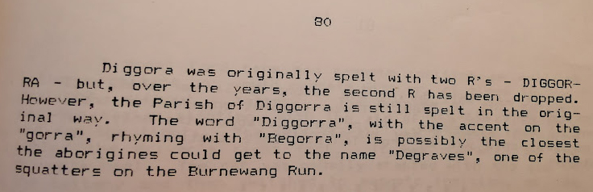
- Church corner on the Brick Church Road – Wesleyan Services
- Church built 1873 – served the community for over 100 years.
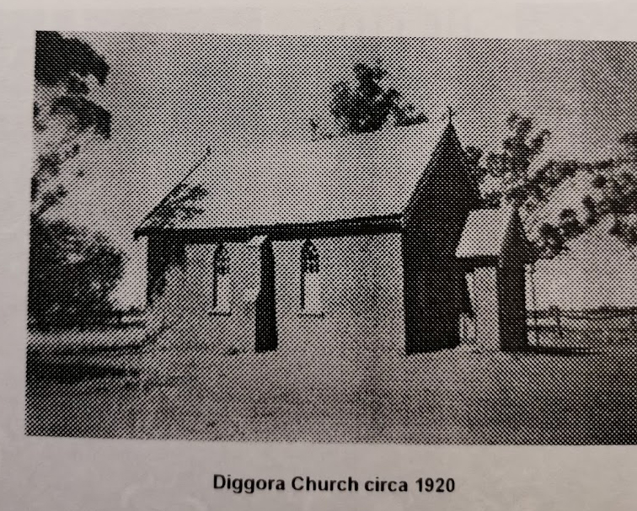
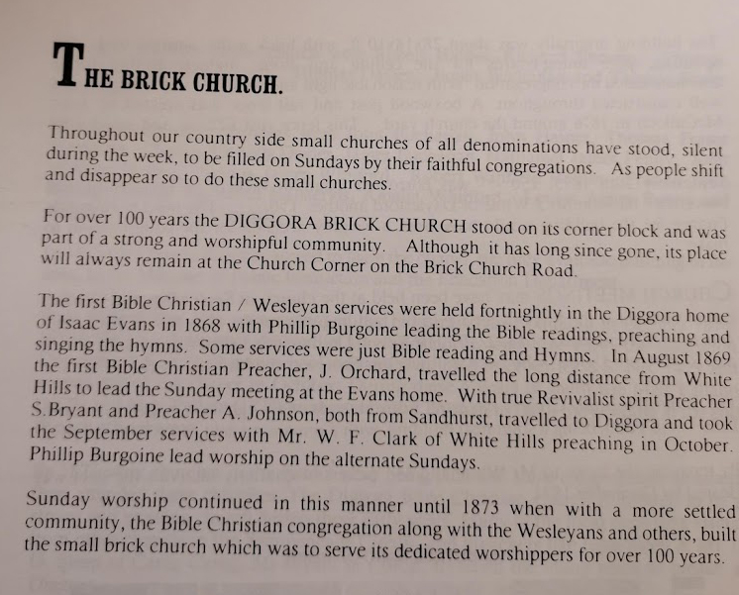
- 15,500 locally made bricks – shingle roof
- State School #1413 commenced in the Diggora Chapel building in October 1874
- By mid-1930’s with reduced population, only 8 families attended the church regularly
- Services discontinued in 1967
- Because of vandalism, the building was demolished in 1977.
State School
- South east corner of 241 (Isaac Evans land) and 200 links from the corner
- School yard on the S/E corner opposite the Brick Church
- School opened in 1874 – 37 students with an average of 22 attending
- School later moved directly opposite the Church
- School closed 12/11/1907 due to lack of students
- School moved to Warragamba
Diggora Hotel
- Diggora Hotel (McCarthy’s) first licensed June 1875 – closed 1897. Only bricks and timber remain today and dome brick lined well – near Peppercorn trees
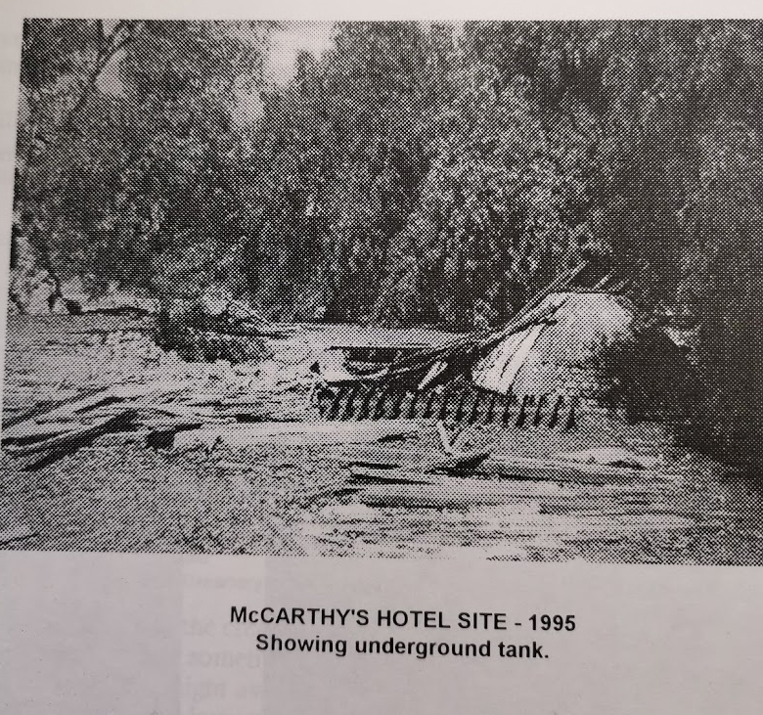
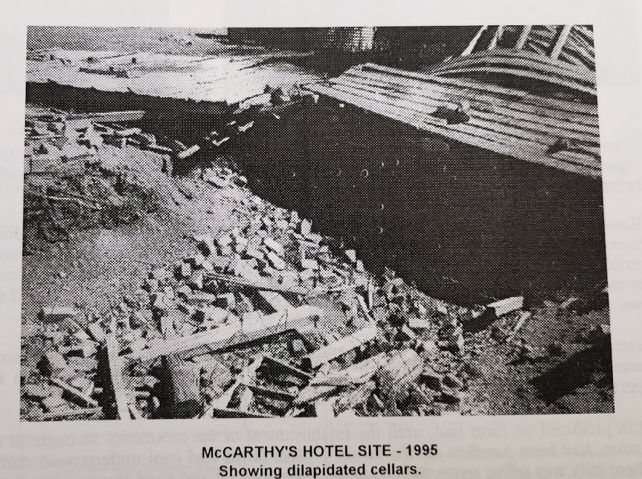

- 1876 Diggora Sports Club Races were held on Mr. P. Rooneys course
- Second Hotel called Junction Hotel 2 miles west of Diggora Hotel run by Mr P. Rooney. His Hotel was burned down, rebuilt and reopened.
- Cricket was played on the paddock that had been cleared for the race course.
Hanley Creamery 1892 – 214 Diggora Road
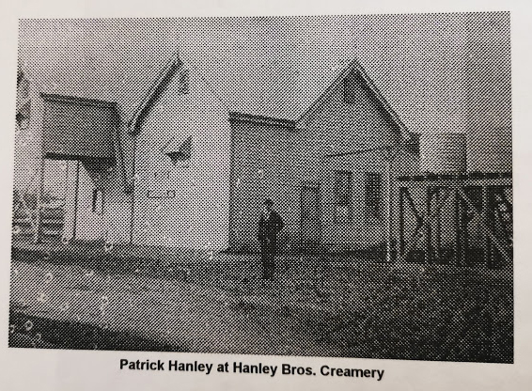
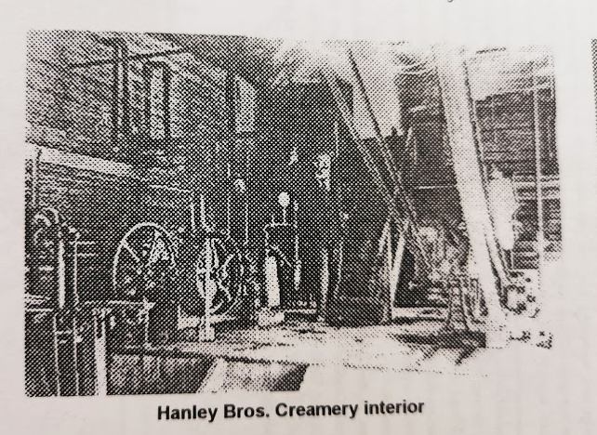
- Most farms had cool underground dairies where milk was left to settle, the cream skimmed off and hand churned into butter for domestic use or sale. It operated for 10 years.
- The milk was carted to the creamery by horse and cart. After separating the remaining mil went back to the farm to feed the pigs and cream taken into the dairy at Rochester.

- Water was raised from wheels by water whim. The horsed walked around in a circle to raise the water. One bucket was lowered as the other was raised.
- The horse then turned around and walked in the opposite direction. These operated until 1920
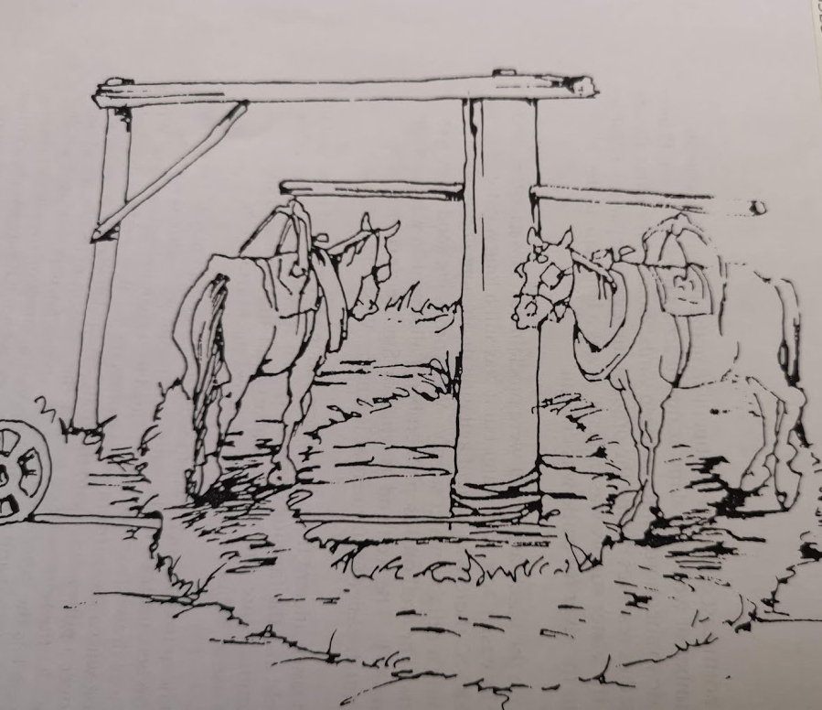
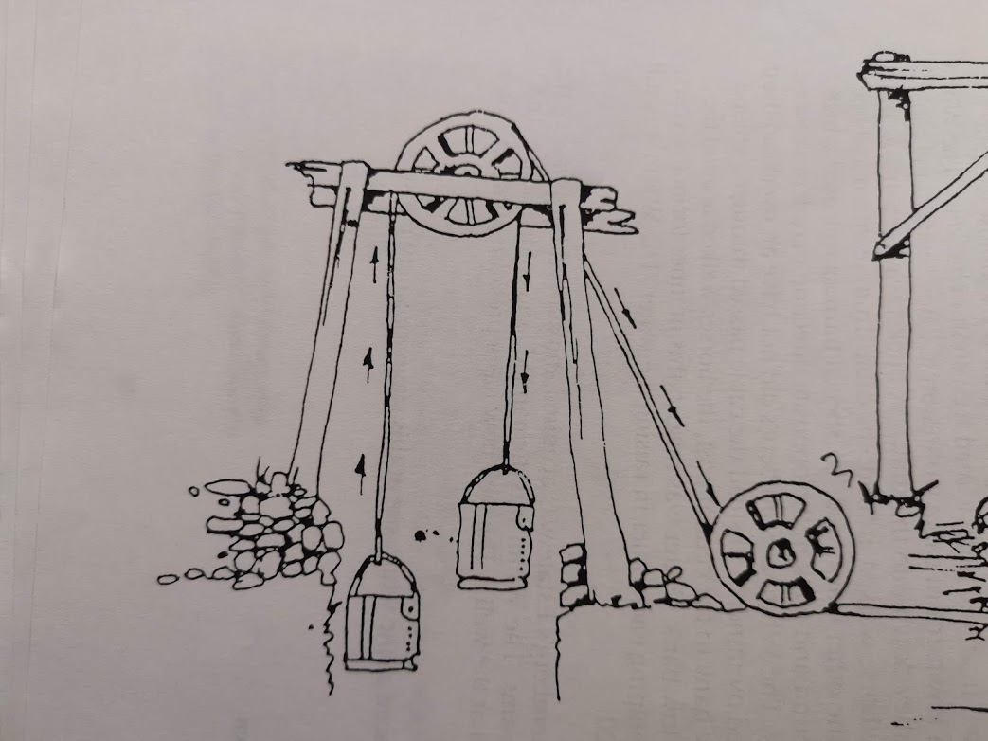
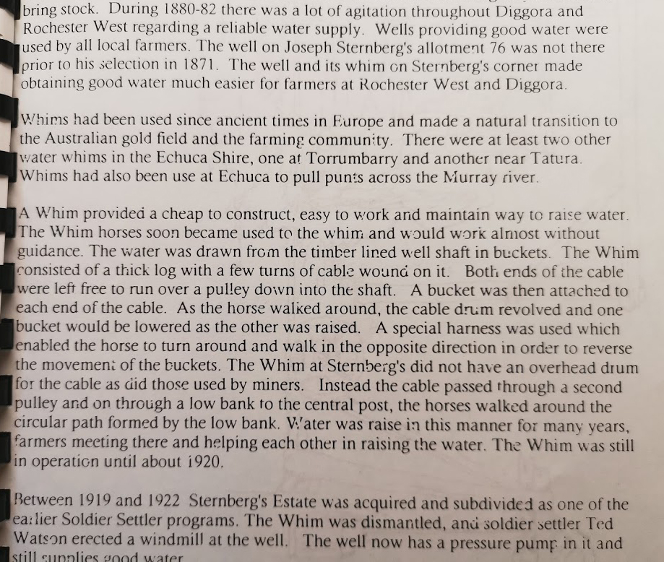
- Outstation shepherd huts to mind sheep and guard them 7 days a week. The shepherd was supplied with food from the squatters homestead once a week or fortnightly. That was the only time to see another human being.
- Clearing of the land was done with picks, shovels and axes.
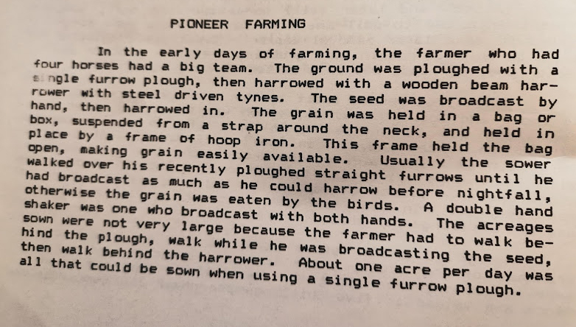
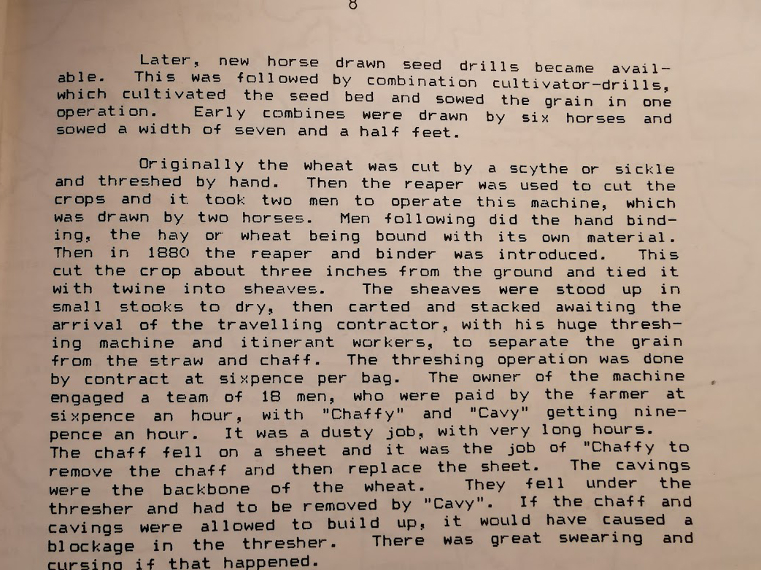
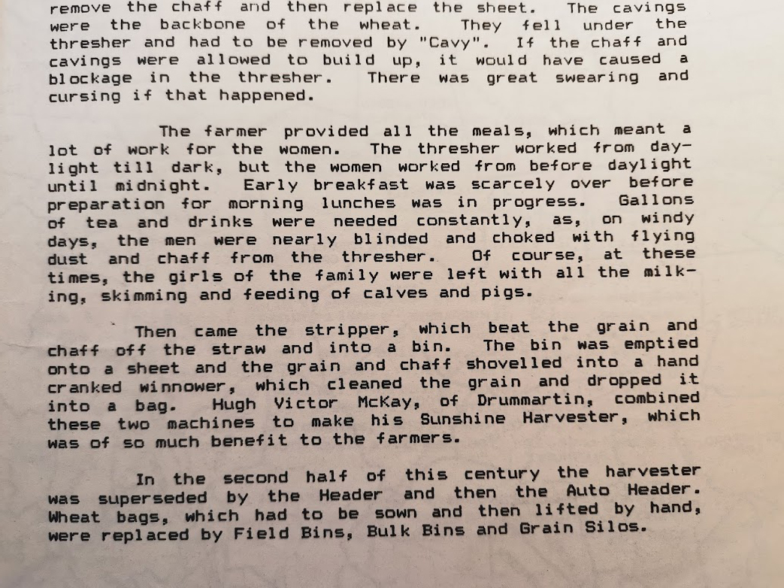
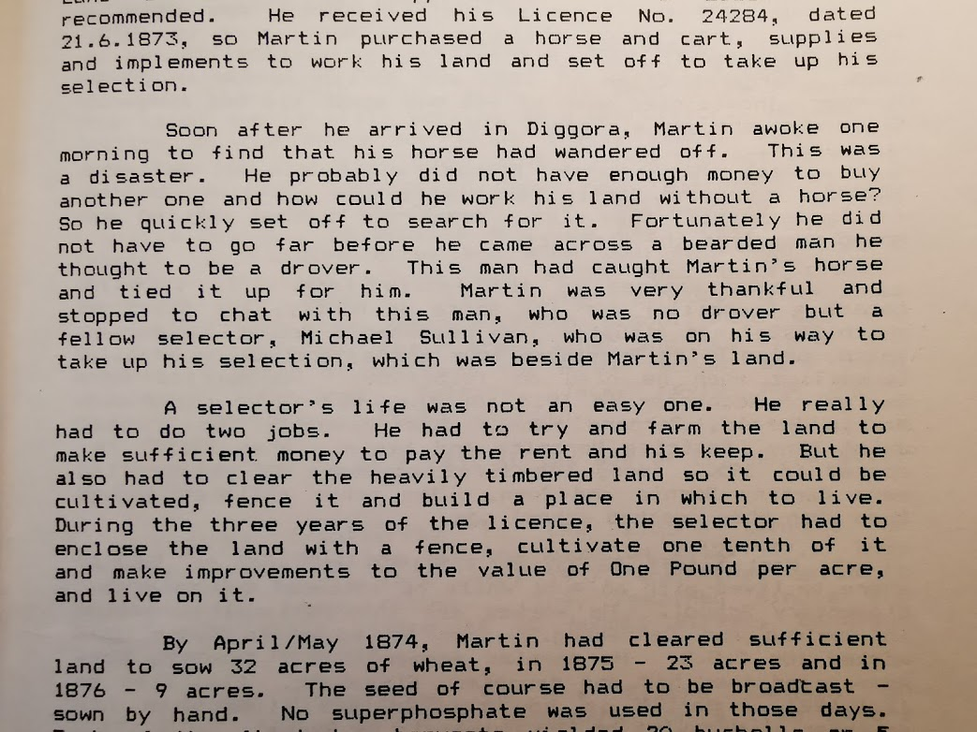
- One tenth of the land had to be cleared and cultivated.
- Timber was used for the buildings
- The ground was rock hard around the trees.
- Trees were ring barked
- Winched were attached to the trees and pulled over by horses.
- Homes were usually one room only. The kitchen was built separately because of the danger of catching fire.

KATHLEEN GORMAN
- John Garth and Margaret Garth. Their son was Simon (1896 – 1988) married Mary Maloney but she died soon after. Then in 1926 he married Kathleen Gorman. They lived at Diggora after the marriage and the moved to a farm closer to Rochester.
DANIEL O’GORMAN – later Robert McGregor married Marie Bonnar in 1906 and purchased the property selected by Daniel O’Gorman.
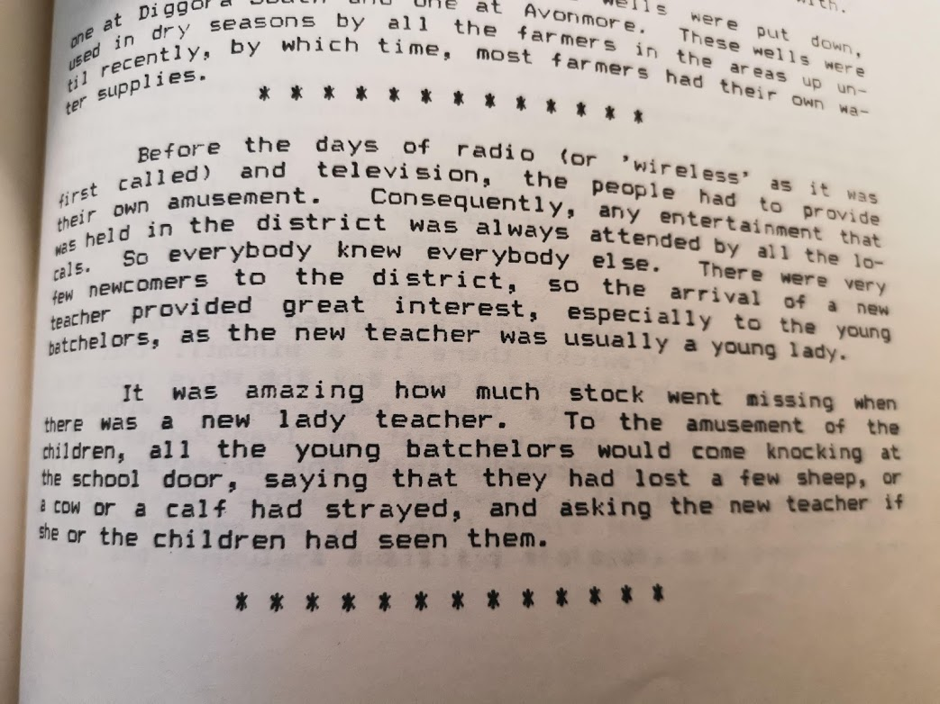

STATE LIBRARY OF VICTORIA
- Memories of Diggora, its school and its people SLTF 994.54 D56C
- Significant sites at old Diggora SLTF 994.54.D56R
