NED’S EXTENDED FAMILY IN MELBOURNE
Uncle Ned’s life seems to have been divided into thirds. He spent his formative years as a dairy farmer living in the family home located about 3km along the Tarranlea Road on the outskirts of Coleraine. Subsequently, with the death of his sister in 1927, Ned sold the farm and relocated into the township of Coleraine to pursue his interest of setting up a business and changing his focus to his passion for music. Finally, with the outbreak of World War II, Ned sold up once more and moved to Melbourne.
During World War I, Ned lived at 34 Albion St. South Yarra near the Prahran Market but this time he took up residence at 97 Armstrong St. Middle Park in a beautiful location on the edge of Port Philip Bay just down from St. Kilda Pier. Again, he volunteered at the munition’s factory and after the Second World War was over, he worked for General Motors Holden on the Assembly line at Fisherman’s Bend. After some time owing to ill health, he had to resign.
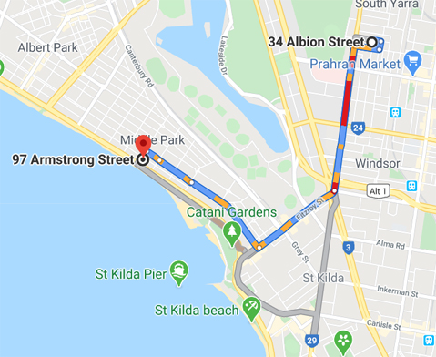
Ned loved his food and enjoyed talking for hours. In Coleraine he would often call in to have a meal with the Eveston’s who lived not far from his own family home. Uncle Ned had a great knowledge of his extended family relationships in Melbourne, which he nurtured by regular social contact with family members including our own in Ringwood. Looking back, I wish I could have asked Ned a heap of questions about the early days. However, I have acquired through my family-history research over many years most of the answers I was seeking.
Years ago, it was quite a revelation to me to learn that the first Keane/Kane family member to come to Australia was Aunty Mary Madigan, who was born in 1819 and left Britain on the ship ‘Wanata’ arriving in Victoria in 1853. She decided to live at 359 Canning St. Nth Carlton in an old style wooden house.
My great grandfather, Daniel Kane (1839-1909) aged 23 and illiterate, (hence the change in spelling – should have been Keane), left Liverpool on 26th March 1866 on the ship “Star of India” for a voyage of 140 days.
On disembarking in Melbourne, he contacted his aunt, Mary Madigan, at Canning St. Carlton, but soon left for Mt. Cole near Ararat where he earnt a living by being a carrier of timber. By 1869 at the age of 30, he found his way to Coleraine and married Johanna O’Donnell aged 26 who had arrived in Australia 2 years prior to him. They were married in Hamilton on 13th Oct 1870.
Daniel’s youngest sister Ellen, (born 1849) decided also to make the long journey to Australia by assisted passage at the age of 18 in 1867 on the ship ‘Queen of North’. After disembarking in Melbourne, she was met by her aunt Mary Madigan and stayed with her at 359 Canning St. Nth Carlton. Three years later, and the same year as her older brother Daniel (our great grandfather) was married in Hamilton, she married John McNamara from Bathhurst N.S.W. on 19th April 1870 in St. Francis Church Melbourne. The Celebrant was Father George V Barry.
Ellen and John started their married life in a two-storey stone house at 393 Canning St. Nth Carlton near Fenwick St and only about 100 metres up the road from her aunty Mary Madigan who lived at 359 Canning St.
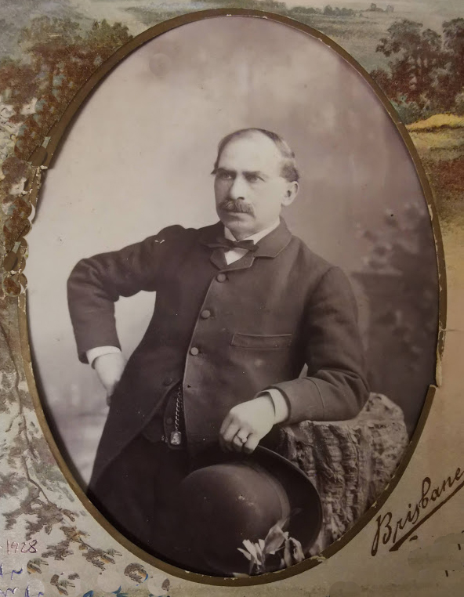
John McNamara (1846 - 1928) Photo taken approx 1890 aged 45
John McNamara husband of Ellen (1848-1923) was born in 1840's and came from Bathurst or Goulburn and lived at Canning St. where there was a lane close by. He had about 4 blocks and grew lucerne in the front yard for the horses. He had 3 draft horses and stables, as well as ducks and lived in an old style wooden house. He was a sand carter and filled in the potholes from Elizabeth St. to the Sarah Sands hotel which wasn't paved. He is buried at Melbourne General Cemetery.
John and Ellen raised 11 children.
1. John born 1871 (eldest) married Moy Fitzgerald. He had 4 children (John, Kathleen, Desmond and Nan who became a Nun Sr. Euphrasia of the Good Shepherd Order).
2. Margaret born 1873, married Patrick Brosnan and had one son.
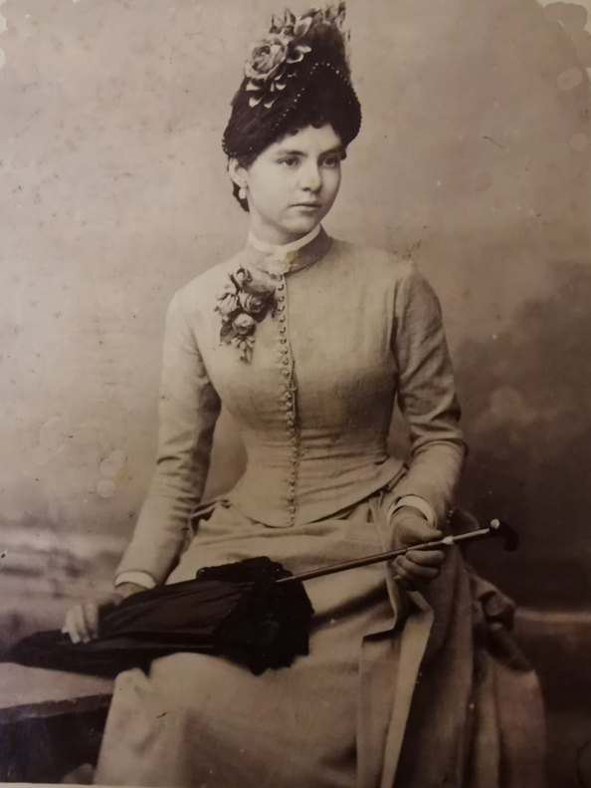
Margaret (Mag) McNamara aged approx. 20 March 25th 1893
3. Thomas born 1875 (Tom) died 1936 aged 60 - never married.
4. Mary born 1877 - 1957 St. Brigid’s schoolteacher later a dressmaker.
She married Gerald Brosnan in 1903 St. Brigid’s Nth Fitzroy.
Their children were:
Kathleen Brosnan born 1904 (Arts Degree)
Eileen Brosnan (1905-1978) Educated at St. Brigid’s - played the violin but never married
Mary Brosnan 1908 MA Dip Ed
Dr. Gerald Brosnan 1911 - 1989 St. Pat's East Melb - Medicine Melb Uni
Pauline Brosnan 1913 teacher High School married Herbert Moran brother of Bishop Moran
Kevin Brosnan 1915 - 1985 champion middle distance runner,
Dolly (Annie Kane 1897-1988) stayed with the Brosnans often in Melbourne and received cards from them which I saw myself.

5. Ellen 1879 (known as Nell),
(known as Nell) born 1879, married twice (Edwards then Coffee) Nell looked after her mum and dad. She had 2 marriages but no children.
6. Daniel born 1881 - had 6 children
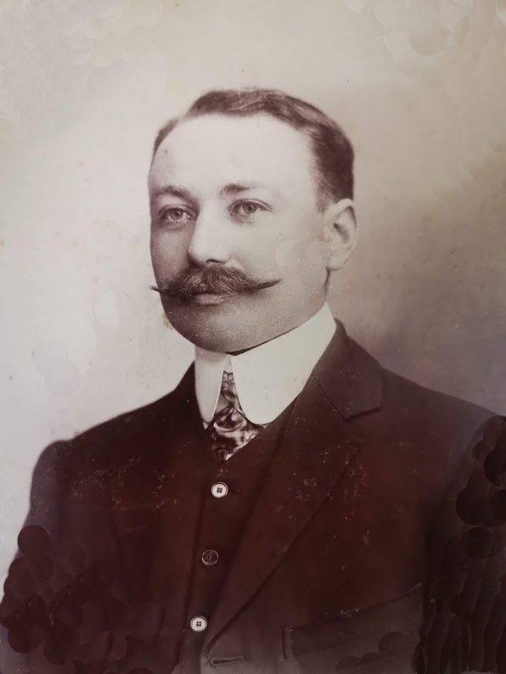
Daniel (Dan) McNamara (photo approx.1910)

7. Michael born 1883 had 4 children - Michael McNamara was a big man and died of pneumonia. He had horses like his father and lived around Brunswick. When he died the boys were put in the orphanage at Geelong. One of the boys became a chemist at Surfers Paradise later becoming a millionaire owning a string of properties at Mermaid Beach.
8. Kathleen 1884 (‘Kate’ died aged 18 – Cheltenham – heart failure – acute mania ‘bipolar’ – four days),
9. Annie born 1885 (known as Doll), Ned Kane use to visit her often. She married a Johnson. On Jan 6th 1916 Miss McNamara was thrown out of a buggy driven by Tommy Kane (son of Daniel Kane the Blacksmith). (Reported in the Coleraine Albion) She was no doubt the daughter of Ellen Keane who had come up from Melbourne to Coleraine to visit her relatives. Most likely it was Annie (Doll) McNamara and she would have been 27 years old at the time. She and Uncle Ned were about the same age and were good friends. She most likely stayed at the Kane house on the Tarranlea Rd. with Uncle Ned and his half-sister Margaret.
10. Hannah born 1887(known as Flo) and died 1960 aged 69 - 2 children Ken Baillie (I knew him and visited him and his brother Phillip a couple of times).
11. Joseph Peter 1892 McNamara (died aged 10 –Tubercular Lymphadenitis and Broncho Pneumonia).
Nineteen years after John and Ellen McNamara were married, Ellen and our great-grandfather’s aunty, Mary Madigan, died on 6th July 1889 of chronic bronchitis after 4 weeks of illness at the age of 70. She had been 36 years in Victoria, never married and is buried in the Melbourne General Cemetery at the Northern end.
Ellen Keane/Kane (McNamara) was called “Mackie”. She was a quiet, religious lady and people remember the black shawl she always wore.

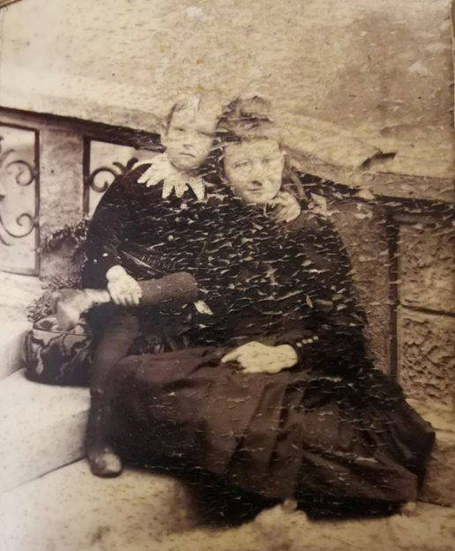
Ellen (Keane) McNamara with Joseph Peter McNamara (1892-1902 son) age 6 (Photo approx. 1898). Ellen was said to be quiet and religious.
Uncle Ned Kane had a lot a contact with his relatives, the McNamara (Keane) family, over the years in Melbourne. He was about the same age as Annie (Doll) and her sister Hannah (Flo) McNamara. On one occasion he had to chaperone Ann and Hannah (Doll and Flo). They wouldn't let him into the carriage of the train, so he had to travel in the carriage next door. They went to the end of the line at Williamstown. Ned had to check if they were still there at each station. When he came back, he said he would wash his hands of them, so he was given the name of 'Pontius Pilate'. Apparently, if Annie (Doll) and her sister Hannah (Flo) disliked someone, they wore a big hat preventing their companion from geting too close. If they liked somebody, they wore a small hat.

JOHN KEANE (born 1841 was Great Grandfather’s younger brother) who stayed in Ireland and lived until 90, but his son John Keane (1868–1931) came to Australia and that started a whole new branch of the family. His daughter was Pat Deany and her daughter was Elaine Sandsodden. Mum often corresponded with Pat and Elaine who sometimes came to Daisy St. for afternoon tea.
Pat Deany had a sister Nelly (she never married) and Ned was ‘keen on her’. She worked at the Railway Refreshment rooms and she was quite attractive.
Uncle Ned often frequented stage shows and movies in his spare time. He saw the musical "Singerly" quite often. It is said that he had a crush on someone in the show. Ned saw the movie ‘South Pacific’ made in 1958 over 20 times. He was keen on the leading lady Mitzi Gaynor.
Uncle Ned’s last place of residence was 51 Nimmo Street Middle Park.
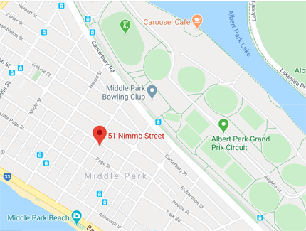
At the end of his life he broke his leg and was in hospital for many months prior to his death. He celebrated his 80th birthday 2 weeks before his death.
Died August 26th, 1966 age 80 in a private nursing home in St. Kilda.
Requiem Mass was celebrated in St. Joseph's Church Coleraine by Fr. Mc Dermott.

Vin Kane still lives in Canberra today and is the grandson of Daniel Kane the Blacksmith in Coleraine. Ned once spoke to Vin’s mother Catherine ‘Kitty' Gleeson and told her that he had a sister and then broke into tears. His sister Margaret who died in 1927 had been very special to him. She had been his only sister and had taken the place of his mother.
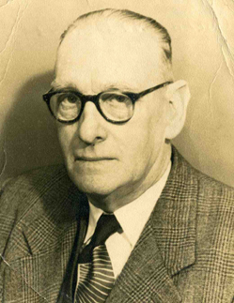
Ned was a very nice man and a thorough gentleman.

Edward David Kane’s Will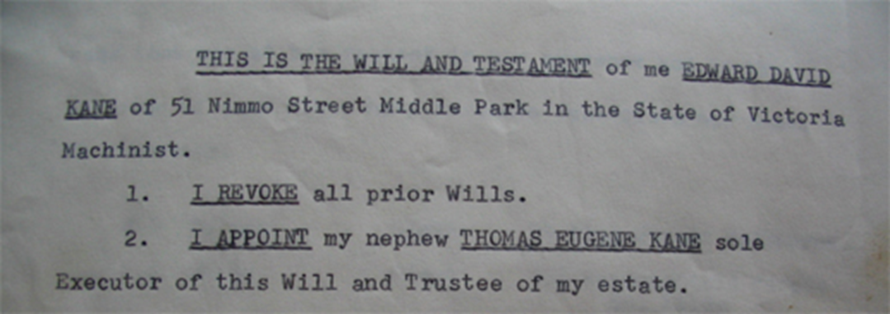
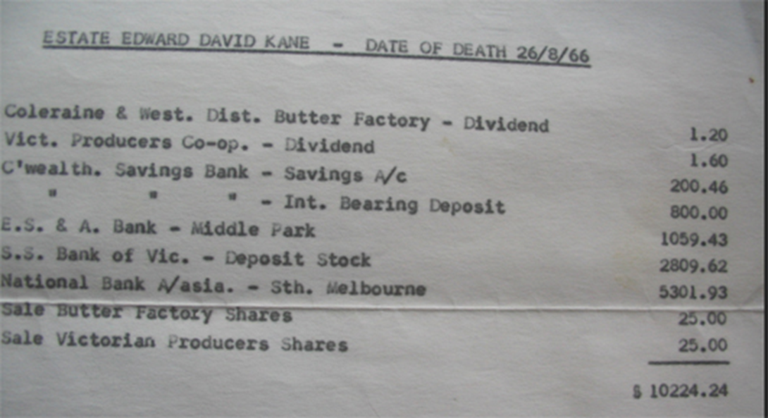
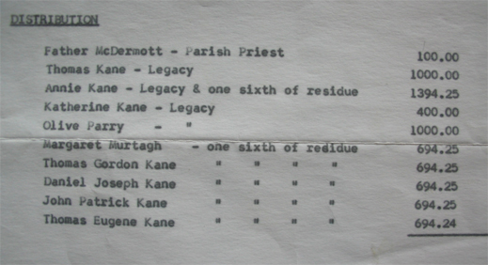

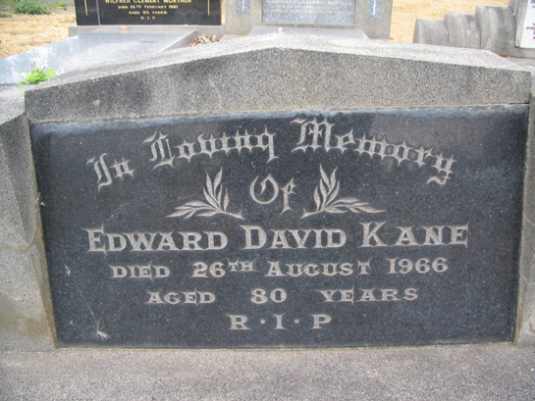
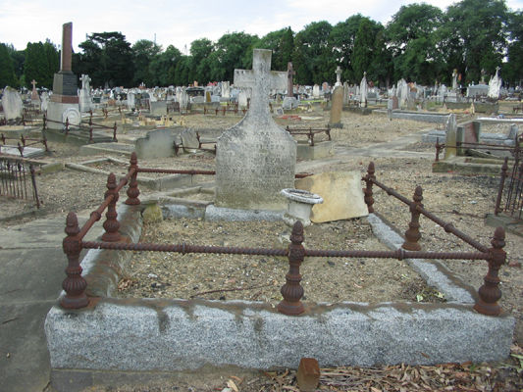
Ellen McNamara's grave in the Melbourne General Cemetery sister of our great grandfather Daniel Kane. (1839-1909)
In

Loving Memory

Of

(PICTURE OF A SHAMROCK)

ELLEN McNAMARA

BORN CO. LIMERICK IRELAND

DIED 1 st Dec 1923 AGED 74 YEARS

ALSO KATHLEEN

DAUGHTER OF THE ABOVE

DIED 2 nd APRIL 1902 AGED 18 YEARS

ALSO JOSEPH

SON OF THE ABOVE

DIED 9 th OCTOBER 1902 AGED 10

ALSO MARY MADIGAN

AUNT OF THE ABOVE

DIED 8 th JULY 1889 AGED 70 YEARS

ALSO JOHN McNAMARA

HUSBAND OF THE ABOVE

BORN BATHURST N.S.W.

DIED 17 th MAY 1928 AGED 79 YEARS

(And a small tombstone to the side of the main tombstone)

ALSO

THOMAS PATRICK

SON OF THE ABOVE

DIED 8 th MARCH 1936

AGED 60 YEARS

R.I.P.

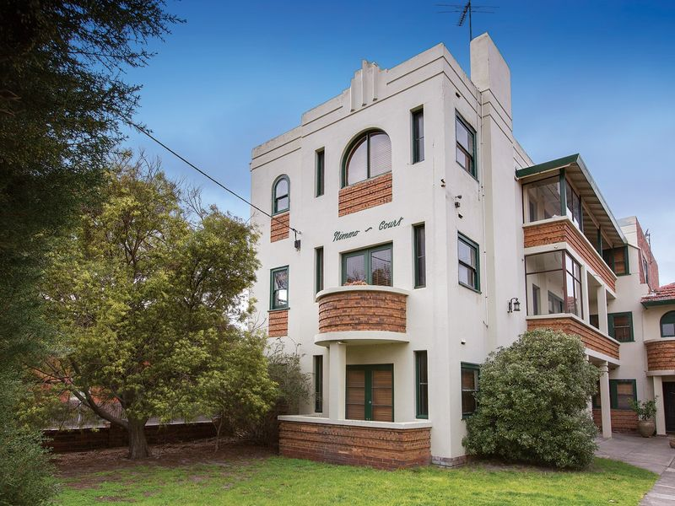
Ned’s last residence at 51 Nimmo St. Middle Park

