The life and times of our forebears in Ireland
If you were a Catholic born in Ireland, your family history revealed a woeful tale of injustice, discrimination, famine, disease, and cruelty on a scale unimaginable for those of us lucky to live in a place like Australia today. It’s not surprising that many Irish people chose to emigrate to America and Australia to seek a better life.
In the early 18th Century, Catholic education in Ireland was greatly compromised by the 1709 amendment to an Act which decreed that “any public or private instruction in the Catholic faith would render teachers liable to prosecution”. As a result the only way students could be educated in this environment was in ‘hedge schools’, so called because the students would hide behind hedges to receive instruction from their teacher. Lookouts were assigned to warn of British soldiers coming and once the signal was given everyone scattered. Mass services were also held in this manner. Priests found breaking the law were persecuted or shot. These laws were not reformed until 1782.
Some middle class Catholics in the south had business’s trading livestock and other supplies onto ships bound for British colonies, but most were subsistence farmers, worked manually as occupations as stonemasons or similar menial occupations. The poor, and the sick, especially in the cities, struggled to achieve even the barest of human needs for their existence. In contrast, wealth and success in Ireland was reserved for the Protestant population even though the Catholics outnumbered them by three to one but were powerless and marginalised.

To make things worse a famine struck Ireland between 1739 and 1741 in which 400,000 people died out of a total population of 2 million. One in three of the rural poor died and starvation was made worse by outbreaks of typhus and dysentery.
The Kane family history dates back to 1775 when Edmond Kane was born in Kerry Ireland. He married Margaret Curran in 1800 and their son John Keane was born approximately in 1801.
Similarly, the origins of Eveston family history can be traced back to a time when Catholics held only 7% of Irish land. Catholics faced oppression under British Penal Laws enforced by the authorities. A ruling class which became known as the ‘Protestant Ascendancy’ sought to ensure dominance with the passing of a number of laws to restrict the religious, political and economic activities of Catholics beginning in the 1720’s. For example:
- Exclusion of Catholics from most public offices
- Bar from membership in either the Parliament of Ireland or the Parliament of England.
- Disenfranchising Act 1728, exclusion from voting until 1793;
- Property Act – Catholic inheritances of land were to be equally subdivided between all an owner's sons with the exception that if the eldest son and heir converted to Protestantism that he would become the one and only tenant of estate.
- Ban on converting from Protestantism to Roman Catholicism.
- Ban on Catholics buying land under a lease of more than 31 years; repealed 1778.
- Ban on custody of orphans being granted to Catholics.
- Ban on Catholics inheriting Protestant land
- Prohibition on Catholics owning a horse.
- Roman Catholic lay priests had to register to preach under the Registration Act 1704, but seminary priests and Bishops were not able to do so until 1778. At least they could register; the English Popery Act 1698 awarded a bounty for arresting a priest.
- When allowed, new Catholic churches were to be built from wood, not stone, and away from main roads.
- No person of the Catholic religion shall publicly or in private houses teach school or instruct youth in learning upon pain of twenty pounds fine and three months in prison for every such offence. Repealed in 1782. Reforms of the British Penal Laws began in 1778 and the majority of the laws were removed in the period 1778–1793 with the last of them of any significance being removed in 1829. However, the long-drawn-out pace of reform ensured that the question of religious discrimination dominated Irish life and was a constant source of division.

Inspired by the American Revolution (1775-83) and the French Revolution 1789-93), Thoebald Wolfe Tone who formed the Society of United Irishmen, led a rebellion in 1798 to bring about democratic reform and Catholic emancipation. The rebellion was led by the Presbyterians angry at being shut out of power by the Anglican establishment and joined by Catholics, who made up the majority of the population. The Catholic population were in a sorry state with no political power, little recourse to the law and were economically downtrodden. The rebellion started in Dublin and spread south to Wicklow.
In County Wicklow, (where the Eveston’s/Evison/Evessons originated), large numbers rose up, but chiefly engaged in a bloody rural guerrilla war with the military and loyalist forces. General Joseph Holt led up to 1,000 men in the Wicklow Mountains and forced the British to commit substantial forces to the area until his capitulation in October.
A French army which landed in County Mayo in support of the rebels was overwhelmed by British and loyalist forces. The uprising was suppressed by British Crown forces in a quick and brutal manner with a death toll of between 10,000 and 30,000. Yet, from that time onward, this rebellion was forever remembered, and the Irish people never lost sight of eventually achieving freedom and basic human rights.
Reforms of the British Penal Laws began in 1778 and the majority of the laws were removed in the period 1778–1793 with the last of them of any significance being removed in 1829. However, the long-drawn-out pace of reform ensured that the question of religious discrimination dominated Irish life and was a constant source of division.
Charles (Eveston/Eviston/Evesson) was born about 1780 at Tinakilly (Tinnakilly), Rathdrum Parish, County Wicklow Ireland. He married Margaret McGraph. Two of Magaret’s sisters were Bridget (‘Bidy’) McGraph and Judith McGraph). Charles was a stonemason, an occupation which was shared by some of his descendants even when they immigrated to Australia.

One of the biggest problems facing Ireland in the 19th century was the ownership and tillage of the land. Poor agricultural techniques, inefficiency, reduced crop yields and unfair rent and land tenancy resulted in crop failures in 1800, between 1816 and 1819 and again in 1822. The effects were devastating with a shortage of food and was accompanied by disease. From 1816 to 1842 there were 14 partial or complete famines in Ireland.

My great, great grandfather, John Keane was born in 1800 and was married to Margaret Madigan in Athea Co Limerick 3/3/1829. They raised seven children:
- Mary born 23/11/1829, Married 29/7/1849 to Michael Wall
- Edmond - Born 26/7/1832 – Married- 30/12/1857 to Mary O’Connor
- Margaret - Born - 9/4/1835 - Married 13/2/1870 - to Michael Kargen
- Daniel Born 1839 - To Australia 1866 – Married - 13/10/1870 - to Johanna O’Donnell – Died 30/11/1909 (My great grandfather)
- John - Born 25/7/1841 – Married 23/1/1868 to Bridget Leamy - Died 9/1/1932
- Ellen - Born 8/4/1845 - To Australia 1867 – Married - 19/4/1870 St. Francis Church Melbourne - to John McNamara – Died 1/12/1923 - 11 children.
- Timothy – Born 19/4/1848
Cobh is about 15 miles away from the city of Cork and is the most important port in Ireland. It was the departure point for Irish emigrants in the 19th century. The town was also the last port of call for the Titanic before striking the iceberg.
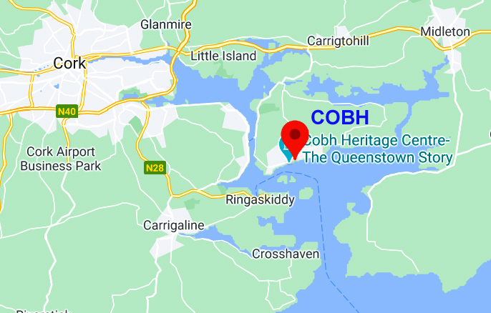
Daniel Kane (my great grandfather)

Left Liverpool 26 March 1866
Voyage 140 days
Ship: Star of India
Age 23
Captain B.B.Sharp
Tons 1690
Total crew: 350
Occupation: Labourer
Total English on ship: 103, Scots 14, Irish: 108 males, 71 females, 8 children, Foreigners: 5. Total: 379
Arrived in Australia: 1866
Between 1828 and 1837 almost 400,000 Irish men, women and children departed for a new life in America. For the poorest Irish who would never get enough money together for a ship fare to America, Britain was the final destination. From 1830 to 1835 some 200,000 Irish men and women went across the Irish Sea and found new homes in the towns and cities of England and Scotland. By 1841 over 400,000 lived permanently in Britain. They were treated suspiciously because of their religion, given the worst jobs and often fell into lives that were dominated by drink, crime, and violence. They were regularly attacked by Protestant mobs who hated them for their religion.
In the 1830’s rural Ireland was a violent land. Murder, injury, and destruction of property was endemic. Crime was a common feature of daily life. Anyone owning or renting land had to pay an annual tithe.
The Catholics of Ireland needed a leader and DANIEL O’CONNELL started the Catholic Association in 1823 and with his influence the British Government changed the tithe system in 1838.
Also in 1838 the British Government introduced the Poor Law Act which set up 130 workhouses across the country. They took in the poorest citizens in return for hard, often brutal work for which they were given food and a bed. They were horrible unpleasant places.
DANIEL O’CONNELLwanted the emancipation of Ireland, justice, and equality but without resorting to violence. Under the Act of Union all major political decisions were made in London and usually in favour of the Protestant population. Daniel was relatively well off and was educated in the law. He wanted Catholics to vote for Catholic Members of Parliament and to give a voice to everyone. By the time he was done he had a following of 3 million members.
In 1828 O’Connell announced that he, a Catholic, would fight the by-election of Clare. He was the first Catholic since the 17th century to stand for election and he won the seat easily. His ultimate aim was the repeal the Act of Union which tied Ireland to England. In 1843 he held his biggest meeting, and an estimated crowd of one million people came together to hear him speak. Eventually, Daniel O’Connell was arrested and sentenced to 6 months in gaol before being freed, but he couldn’t sustain the energy to re-invigorate his movement. With that, the repeal movement died for the time being in October 1841.
Daniel Kane, my great grand father, had been born 2 years earlier in 1839 and by the time he was 6 years old the first signs of a fungal disease in Irish potatoes appeared in September 1845. In that year one third of the crop was lost but in 1846 the fungus reappeared, and the failure of the potato harvest was near total. With the failure again in 1848 and 1849 the population of 8 million in 1841 fell to 6 and half million by 1851. More than half had died from hunger and disease and the remainder had fled or emigrated. One of the biggest killers during the famine wasn’t actual starvation but the diseases that the weakened bodies succumbed to such as cholera, dysentery, and scurvy. The Irish had become too dependent on the potato for their source of food and many people were trying to survive on plots of land that were too small.
As the result of the famine, the general hardships and lack of hope for the future some members of the Kane family decided to emigrate to Australia.
- Mary (Mackie) Madigan - Came to Australia 1853 died 6/7/1889 buried Melbourne General Cemetery – Unmarried - Lived in Carlton – sister of my great great grandmother.
- Daniel Kane - Born 1839 - To Australia 1866 – Married - 13/10/1870 - to Johanna O’Donnell – Died 30/11/1909 (My great grandfather)
- John - Born 15/12/1868 - married 1896 - died (1931) to Australia – nephew of Daniel Kane.
Key dates:
1870 – Gladstone’s Land Act began a process by which old landlords were steadily replaced by Irish owners of the land.
1875 – CHARLES STEWART PARNELL elected MP for Meath as a supporter of Home Rule. One of the great leaders of constitutional Irish nationalism. Parnell and the home Rulers wanted a separate parliament for Ireland based in Dublin. They also wanted the system of land ownership in Ireland to be reformed.
1885 – the Home Rulers swept the board in Ireland except for the unionist seats of Ulster and the University seats in Dublin with 86 Home Rule MP’s. Unfortunately, Parnell’s relationship with a married woman derailed the Home Rule movement for many years.
1912 – Home Rule Bill successful and due to be enacted in 1914 and then World War 1 broke out putting the whole process on hold.
1915 – The Irish Republican Brotherhood (IRB) planned a rebellion for Easter Sunday 1916 but within a week it was crushed and much of central Dublin was destroyed with 500 dead on both sides. Execution of the leaders made them martyrs. Home Rule was dead also.
1919 – The War of Independence began when two police officers were shot by members of the IRA. It was a brutal war mainly concentrated in the southern part of Ireland. The British Black and Tans were responsible for some of the most notorious killings of the War.
1920 Home Rule created by dividing Ireland. The Unionists would govern 6 counties in Northern Ireland with their own Parliament in Belfast. This was NOT ACCEPTED by Irish in the south.

1920 - Bloody Sunday - Nov 21st - Bloody Sunday massacre at Croke Park still resonates in Irish sport 100 years later. Shortly after the ball was thrown in to start the game, ranks of police and soldiers marched on the ground and opened fire on the crowd. Fourteen civilians died in the massacre and one player. https://www.abc.net.au/news/2020-11-21/bloody-sunday-centenary-gaa-croke-park/12880684

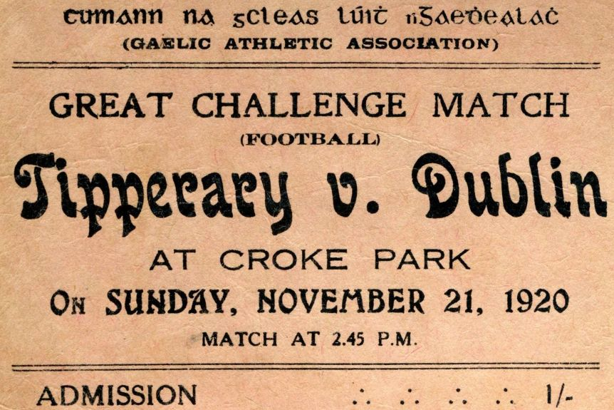

1921 – 1400 people had been killed from both sides, but THE TREATED WAS SIGNED ON 6th December creating a new nation – the IRISH FREE STATE. The sticking points were that of remaining in the Commonwealth and swearing an oath of allegiance to the British Crown which was never going to happen! Enter de VALERA WHO ARGUED THAT IRELAND HAD FOUGHT A WAR TO CREATE A REPUBLIC AND ANYTHING ELSE WAS UNTENABLE.
1922 – The Irish Civil War began but fighting was largely restricted to the south-west of the country. By the end of the War – 12,000 anti-Treatyites were in prison, 77 were executed, 800 Free State troops had been killed and possibly as many as 5000 of their opponents.
1923 – The Civil War ended when de Valera ordered his forces to end the fighting. The Free State forces had won the day and an independent Ireland had come into being, but freedom has been won at a terrible price.
1960’s – The Unionists of Northern Ireland had shown that they had no intention of sharing power with the nationalist Catholic population. So for the next 30 years a bitter war waged between IRA and the forces of the British state.
1972 – Bloody Sunday march which ended with Paratroopers firing 108 rounds of live ammunition into a crowd resulting in 13 unarmed protesters dead and many injured.
1969 – 1989 There were 2761 killed as result of the Northern Ireland conflict.
2001 – By December 2001, the number of deaths attributed to the fighting in Northern Ireland had risen to 3523 and over 40,000 had been injured.
1974 – 1996 Major IRA attacks on Britain and Scotland by the IRA in response to British killings in Northern Ireland.
1998 – THE BELFAST AGREEMENT SIGNED ON GOOD FRIDAY 10TH APRIL
NOBEL PEACE PRIZES WERE AWARDED TO:
- Betty Williams and Mairead Corrigan the founders of the Northern Ireland Peace movement.
- John Hume of the SDLP and David Trimble of the Ulster Unionist Party for their role in the peace talks that led to the signing of the Belfast Agreement often referred to as the Good Friday Agreement; the day on which it was signed.
FAMILY HEIRLOOMS:
- Atlas Encyclopaedia of Ireland 1904 (Ann Morton)
- Family Heraldry and historical Ireland (Ann Morton)
- Daniel O’Connell The Liberator his life and times by M.F. Cusack Published 1872 (Ann Morton)
- The end of Religious Controversy John Milner (Ann Morton)
- Heart of Exile - (large book telling of the Irish struggle) – 1986 (John Kane)
- Kane Family Bible. It was probably given to Daniel Kane and Johanna O’Donnell on the occasion of their wedding in 1870. The forward to the Bible is written by Cardinal Archbishop of Dublin Rev. Dr. Cullen who became a Cardinal in 1867 and he died in 1878 which means the Bible is in this time period. (John Kane)
- Atlas Cyclopaedia of Ireland - Irish Heraldry Topography and Modern History - The History of Ireland - 1904 (very large Bible sized book). Original from Daniel Kane died 1909. (John Kane)
- Family photo album - became popular in the 1860's. This one was purchased in Australia. The cover shows the Melbourne Law Courts. Presented to Margaret by her stepmother Mary Stevens in August 3 1887. Many photos in this family album date back to the early 1860's. One of these in the album is of General Tom Thumb who was a dwarf who toured with Burton's circus in Coleraine in April 1864 according to the "Fields of Coleraine" book by Frank Gardiner. General Tom Thumb was born in the US and he toured Europe. The photo in the album can be viewed on the net also and shows his wedding picture. (Brian Kane)

