‘UNCLE NED’S MOTHER’
It’s hard to understand what it would have been like growing up without a mother’s love. Worse still, was the thought during your life, that your mother left when you were 5 years old never to be seen again. From then on, your only connection to her would be perhaps a few fleeting childhood memories, and her beautiful handwriting on the inside cover of a family heirloom. That was the lot of Edward David Kane whom we affectionately knew as our Uncle Ned. He was in fact our Grandpa Kane’s half-brother.
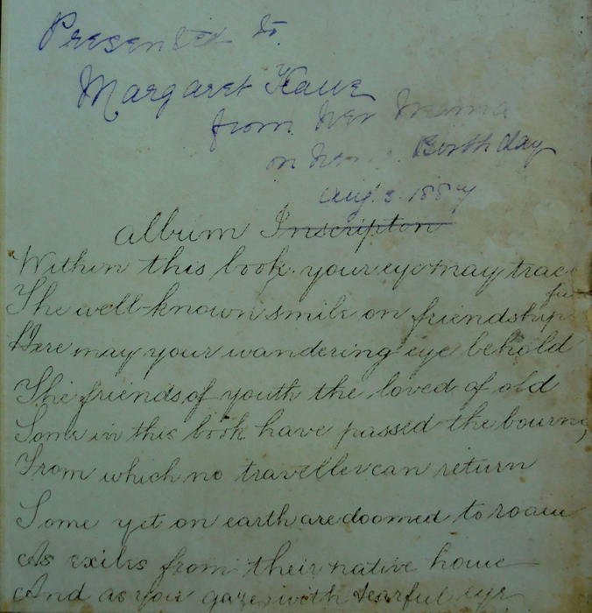
“Presented to Margaret Kane from her Mama on her 10th birthday Aug 3rd 1887 (At this time, Daniel Kane’s daughter, Margaret, was the step-daughter of Mary Jane (Stevens) Kane who was Uncle Ned’s mother.)

Album Inscription
“Within this book your eye may trace
The well known smile on friendship.
Here may your wandering eye behold
The friends of youth the loved of old
Some in this book have passed the bourne (destination)
From which no traveller can return.
Some yet on earth are doomed to roam
As exiles from their native home.
And as your gaze with tearful eye
Sweet memories of years gone by.
Will come again with magic power
To sh………. lonesome hour”.

Feb 21st 1889 Mary Jane (Stevens) Kane).

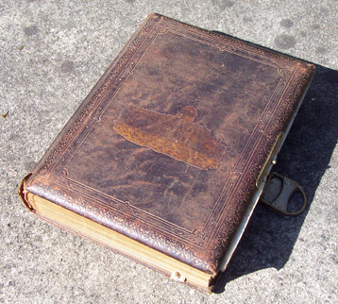
Kane Family Photograph Album dating from around 1870.

Ned was a very kind, likeable man who used to come out from his residence at Middle Park, Melbourne and visit us at our family home at Daisy St. Ringwood. Not owning a car, he would travel by train and taxi usually on Sundays, and his walking stick always accompanied him in his later years due to his painful hips. Mum would warm up the lounge with a wood fire in plenty of time for Uncle Ned’s visit. On his arrival it wasn’t long before the stories began. Mum and Dad loved his knowledge of the old days of Coleraine and his extensive links to relatives and friends of the family.
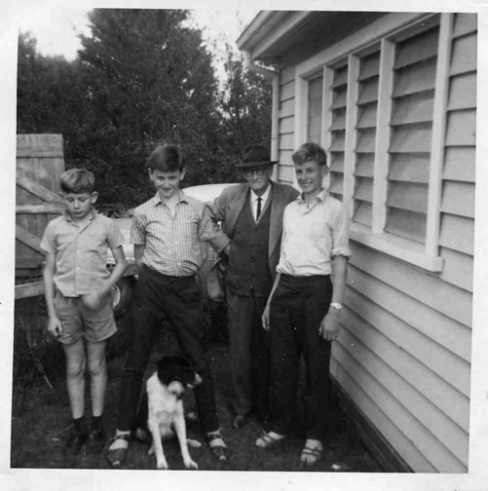
Above photo taken in1964 – John, Kevin, Brian and ‘Tiny’ our Boarder Collie
(Uncle Ned was 68 and this was two years before he died)
It took a lot of searching and sifting through all sorts of information to finally solve the mystery surrounding Uncle Ned’s mother, including her background, disappearance, and re-emergence.
Ned’s grandfather on his mother’s side was Walter William Rickey (1808-1875) who was born in the Parish of Knockbride, County Cavan near the border of Northern Ireland. His occupation in Ireland was a soldier in the 63rd Regiment # 659. Walter was 41 years of age when he married Mariye (Maria) Kennedy (1830-1917) who was 19 at the time on the 16th April 1849 in the Church of England, Dernakesh Townland, Cootehill Ireland about (20 km north east of Cavan).
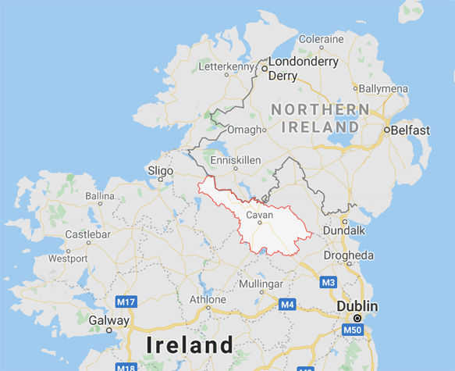
One year later Maria gave birth to their first daughter Annie Maria Rickey (1850-1937) on the 5th December at Killachlare Co. Cavan.
At that time, the ‘Potato Famine’ (1845 to 1849) reduced the Irish population by nearly 25 percent through death and emigration. The people had relied on potatoes for most of their nutrition, but a fungal disease called ‘blight’ destroyed the leaves and edible roots killing the plants, causing widespread starvation.

Was it any wonder that Walter, his wife Maria and 3 year old daughter Anna Marie (‘Annie’ born 5/12/1850) boarded the shipping vessel ‘ROBERT SMALL’ in 1853 en route to Australia? The ‘ROBERT SMALL’ was a 655-ton ship which conveyed convicts and passengers from England to Western Australia and it also carried approximately 100 free passengers. You can imagine the conditions on board and issues like seasickness let alone being pregnant. But that’s exactly what Maria Rickey had to deal with as she gave birth at sea on the 9th May to another baby daughter: Mary Jane Rickey who was later to be Uncle Ned’s mother.



The ‘Robert Small’ vessel.

The voyage over to Australia was hazardous and almost disastrous as seen from this article in the Perth Gazette August 1853.

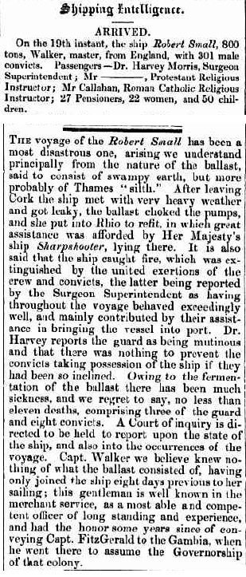

The Rickey family eventually arrived in Western Australia and lived in York, which is the oldest inland town in WA, situated on the Avon River, 97 kilometres east of Perth in the Wheatbelt. Walter Rickey was a guard (EPG) on the convict ship with his family and that was how he obtained his passage to Australia. He worked at Stirling Rd, Claremont and later was posted to York as one of six guards in 1854 and was granted land and a house in Poole St, York where he was appointed a ‘Special Constable’. He died on 29/4/1875 at the age of 67 and is buried in the Pioneer Cemetery in York. Before being married Walter Rickey had previously served in New South Wales Australia (5 years and 13 years in the East Indies). This pioneering family was highly regarded in York.

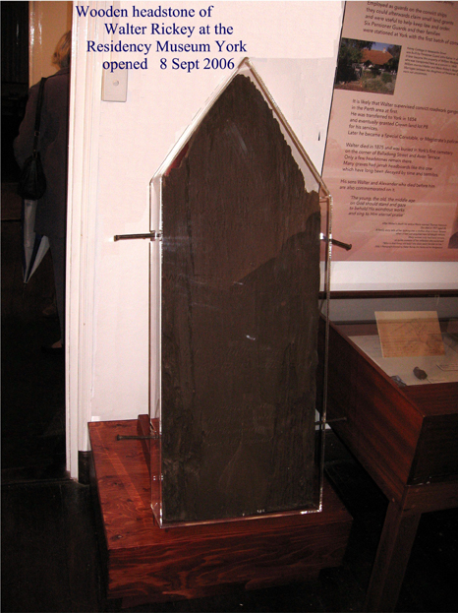

The wooden headstone of Walter Rickey (1808-1875) aged 67 to be seen in the York Museum W.A.

https://enrolledpensionerforcewa.org.au/epf-profiles/r/rickey-walter-63rd-ft/

Maria gave birth to 6 more children over the next 13 years.

1857 Joseph George Rickey 3rd April (1857-1909) York WA (Married Sarah MacKay on 29th November 1886 in the Holy Trinity Anglican Church York Western Australia. Died 22nd November 1909)

1859 Alexander Rickey (1859-1860). He died on 29/2/1860 York WA

1861 John William Rickey (1861-1914) York WA Died 17th Oct Aged 53 Chaff cutting accident: arm severed. (Married Margaret sister of Sarah above on 19th January 1882 York Western Australia. Died 17th October 1914 in York hospital Western Australia.

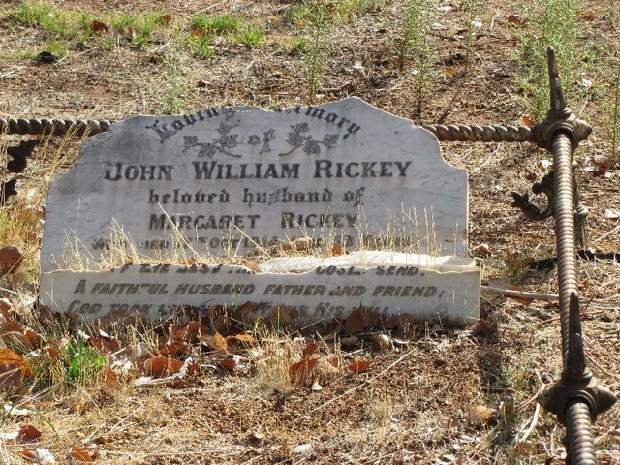

1862 Margaret Rickey (1862- ) York WA

1865 Phoebe Rickey (1865-1938) York WA (Marie James George Stone on 10th June 1889 York Western Australia
Died 20th April 1938 York Western Australia aged 72.

1867 Susan Rickey (1867-1953) York WA Born 23rd April 1867 York Western Australia
Married William Murray on 12th June 1889 Anglican Church York Western Australia
Died on 14th March 1953 East Fremantle Western Australia

Sadly, seven years after the birth of youngest daughter Susan, the father: Walter Rickey died on 29th April 1875 aged 67. His wife was aged 45 years old at that time.

Early in 1869 on the 25th January in York WA, Mary Jane Rickey at the age of 16 married John Stevens who was born in 1845 Hadleigh Suffolk England and had previously lived for a time in South Australia before locating to York WA. Later that same year Mary Jane gave birth to James Stevens (1869-1940) and subsequently to:

Martha Stevens (1873) RIP

Walter Stevens (1876) RIP

Approximately 7 years later in 1883 at the age of 30, Mary left her husband and son James behind in Western Australia and went by ship to Victoria. She had been married at 16 years of age and had lost 2 children in childbirth. When she decided to leave York, her husband John was 38 and her son James was 14 years old.

On arrival in Melbourne and with the lure of employment in Coleraine, Western Victoria, Mary Jane found work as a housekeeper in the town and it was there that she met Daniel Kane (Ned’s father) who was recently widowed in 1883 with 5 sons and a daughter.

Mary Jane seemed to put her previous life behind her and chose to make a new beginning by marrying Daniel Kane on September 2nd 1885. Daniel was aged 50 and Mary Jane was 32.

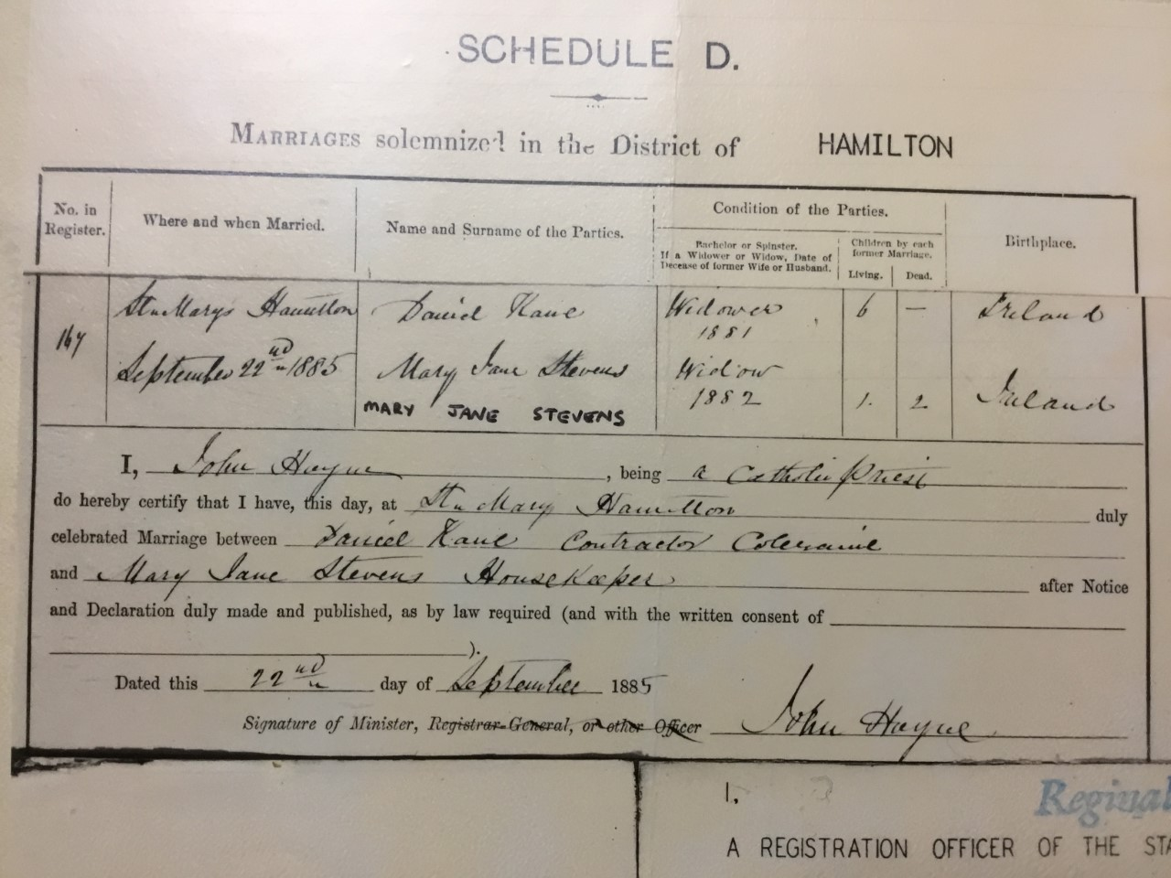

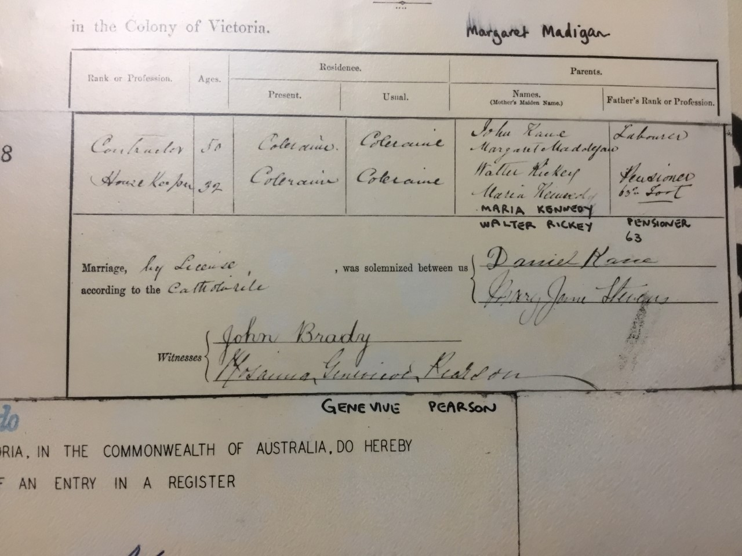

On the marriage certificate, Mary Jane recorded 1 child living and 2 dead and that she had been widowed in 1882. Daniel recorded being a widower in 1881, whereas his wife Johanna had died in Ararat in 1883.

Daniel Kane signed his name with a ‘X’ at his first wedding in 1870 but was able to write his own name as can be seen on this form. Mary Jane signed her name in beautiful handwriting.
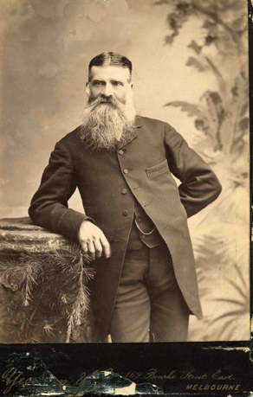 | 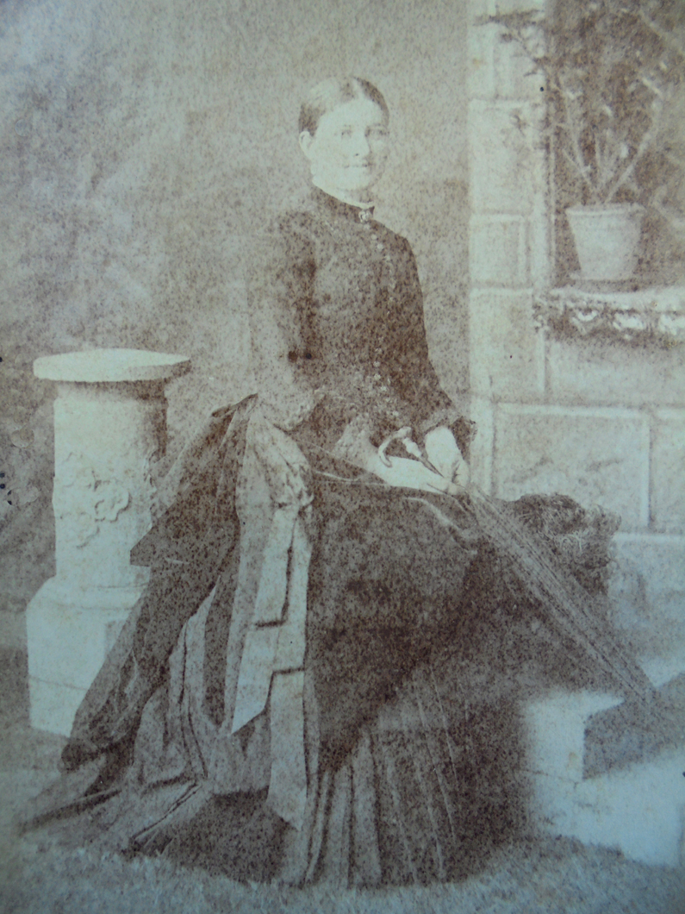
Daniel Kane 1885 Aged 50 | Mary Jane Stevens 1885 aged 32

It must have been quite an adjustment for Mary Jane aged 32 to be living at the large, old- styled, weather board house on Salt Pans Rd. Coleraine with an instant family of Daniel Kane: sons John 14, James 12, Daniel 11, Tom 7, Patrick 6 and daughter, Margaret 8. Daniel Snr was now a farmer after previously being a contractor and carrier. The farm had the usual animals to supply food and milk for the family: pigs, turkeys, cows, sheep, and hens.

Edward David Kane (Uncle Ned) was born on 8th August 1886.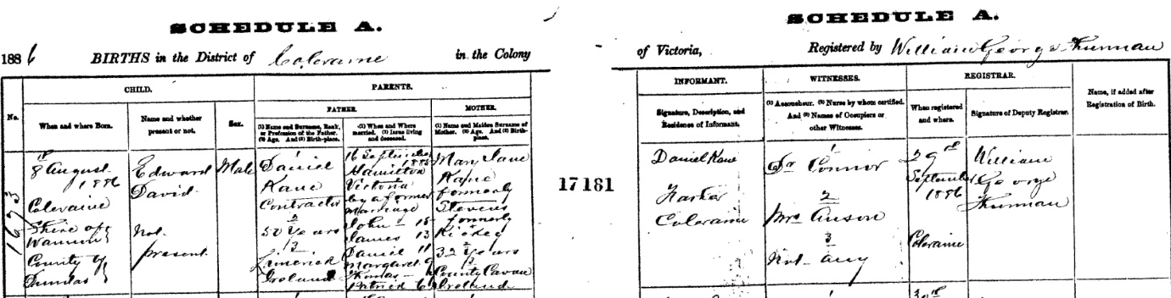

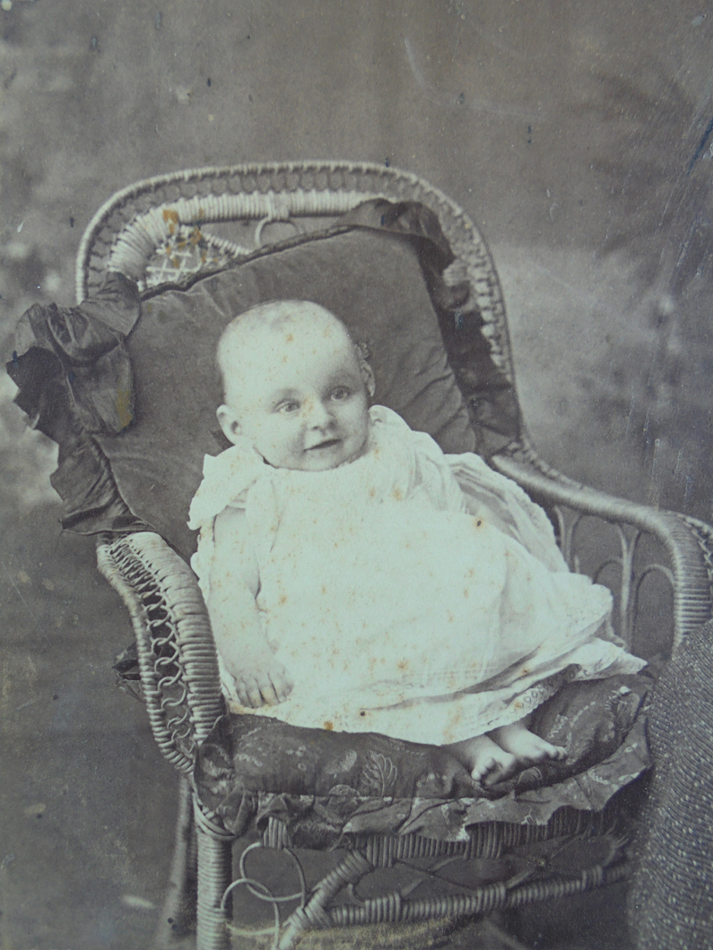

Edward (Ned) Kane born 8th August 1886

During the next 4 years Daniel, Mary Jane and the family lived on the farm located on Salt Pans Rd, Coleraine. There were various families living along this road which was referred to as the ‘Golden Mile’ because of its productivity in livestock and milk. One of the adjoining neighbours at that time were the McAnally’s who lived at the end of a straight lane. As sometimes happens with neighbours a series of incidents led to a ‘Turkey Feud’ in June 1890!
Mrs. Mary Jane Kane v Mrs. C.A. McAnally
COLERAINE ALBION (PAGE 3) 27TH JUNE 1890
At the Coleraine Police Court on Tuesday, before Mr. Johns PM, a peculiar “turkey” case came on for settlement.
The plaintiff was Mrs. Kane, wife of the well-known contractor, and was represented by Mr. E. Silvester; while the defendant, Mrs. C.A. McAnally, a neighbour of plaintiff, had Mr. Samuel on her behalf.
Mr. Silvester said the facts of the case were that Mrs. McAnally’s children were seen urging a dog to attack a flock of turkeys belonging to plaintiff. She was afterwards interviewed and admitted that some turkeys had been killed by a dog urged on by her children.
The witnesses to the case were ordered out of the court until called upon.
Mr. Silvester argued that only trespassing geese could be destroyed under the Impounding Act.
Mary Jane Kane disposed: I am the plaintiff in this case, and I owned 13 turkeys prior to June 14. Consequent on information received by me, I went to Mrs. McAnally’s place on that date. She has 9½ acres joining us. I asked her if she had been killing my turkeys, and in reply she said she had and would kill more yet.
I told her if she did, I would make them dear turkeys for her, and she defied me, telling me with bad language, to do my best.
Mrs. McAnally told me that she could kill them but must not touch them.
I went towards the potato patch and saw one turkey dead under a wood heap.
It appeared to have died a violent death, found another between defendant’s fence and ours – which was also dead. I took them home, and we ate what was edible of them.
By Mr. Samuel: I have never quarrelled with Mrs. McAnally. I have impounded horses of theirs. I did not take down any fencing recently. I am not a boundary rider. (Laughter) The turkeys were tough when stewed. (Laughter)
Margaret Kane, (daughter of Daniel Kane) a little girl, prior to giving evidence, stated, in reply to questions from the Bench, that she was 12 years of age, and that she went to Sunday School and knew the nature of an oath, and that she would be punished if told a falsehood.
The witness then disposed: The last witness is my stepmother. I recollect June 14. I was at our house and heard a dog barking, and the young Moyles sooling a dog after turkeys with sticks and stones.
The dog was called “Friday.” I went home and reported this to my mother. I saw the remains of some turkeys brought home by my mother afterwards.
By Mr. Samuel: The boys called out to the dog, “sool them Friday.” I did not see the turkeys killed. I saw the boys and the dog running turkeys towards the house.
Mr. Silvester recalled Mrs. Kane.
Mr. Samuel objected to the witness being asked any questions, as the object of ordering witnesses out of court was to prevent them corroborating one another.
Mr. Silvester said he simply wished to question the witness as to the appearance of the turkeys, so that the court could form an opinion as to how long they had been dead.
The witness then entered the box, and deposed: The turkeys appeared warm and were bleeding when found by me.
Mr. Silvester said this was the case for the prosecution.
Mr. Samuel suggested that, as there was another action in connection with the turkeys, the Bench should not adjudicate until the evidence in both cases had been heard – the two depending on the same facts. The second action was to recover 10 shillings, the value of the turkeys.
Mr. Johns expressed his intention of suspending his decision until he had heard both cases.
Mr. Samuel said the defendant’s sons stated that they did not sool on a dog, but had drove the turkeys off with a stick, and, in doing so, killed some. The plaintiff annoyed defendant with turkeys and pigs, and it was very annoying to have turkeys trespassing on a grass paddock.
Kane v McAnally: Claim for 10 shillings, damage done to poultry by a dog.
Mr. Silvester for complainant, and Mr. Samuel for the defence.
Caroline Ann McAnally deposed: I recollect June 14. Between 2 and 3 o’clock that say I was sitting with my baby by the fire when I heard a noise of turkeys. I went down the road a little distance, and when I came back, I saw the children in a shed with some turkeys. Mrs. Kane came down afterwards and asked if her turkeys were there. I said they were not but believed some had been killed. Gave her permission to come on the premises to get them. The turkeys were damaging the crop by coming on the ground.
By Mr. Silvester: I have no animosity against Mrs. Kane. I put an advertisement in the paper cautioning the Kane’s not to trespass on my ground. I did this because I had 2 bags of potatoes in a paddock which their pigs had destroyed.
I never passed any remarks to Kane until the 16th when she was driving her buggy along the road, and she stopped it and jumped off to drive my cow off the road. I got it off first. I register my cow on the common same as you do. (Laughter) I said to Kane “Well Mary Ann Cook, you’re not smart enough this time.” (Laughter)
It’s false that I said I would kill all the turkeys I could. My wood heap is on the main road, and the dead turkeys were not in it. One was at the back of my shed, and the other was kicking between my pig sty and Doulls fence when I left it.
The one that Mrs. Kane took from the back of the shed was bleeding. There were no feathers from the turkeys unless from where she was. All that are in the court can search my paddock and they won’t find feathers unless Mrs. Kane put them there. (Laughter)
Mrs. Kane had both the feathers and the flesh of the turkeys. I brought the stick with which they were killed into court, but not the dog. I was sorry the children killed the turkeys. Mrs. Kane declared was when she took the turkeys.
By Mr. Samuel: I did not interfere in any earthly way. I saw the bodies after the turkeys were dead.
Mr. Samuel wished to examine the little boys who were stated to have killed the turkeys, but as Mr. Johns thought it was unnecessary, they were not placed in the box.
The Bench said that under common law, poultry were liable to be killed if trespassing. The only question was if they were destroyed with unnecessary cruelty. He would, however, like to impress upon the parties in cases of this description that it was the duty of owners to keep poultry on their own premises, and not their neighbour’s duty to keep them out.
The cases were dismissed, with each side to pay their own costs.

Commentary on the court case:
So now we have it - the Kane v McAnally feud. At the time Mary Jane Kane was 37 years old from the 2nd marriage to Daniel Kane. Her stepchildren still at home were John 19, James 17, Daniel 16, Margaret 13, Patrick 11 and Uncle Ned aged 5. The two boys were James (Jimmy) Moyles aged 14 and Patrick (Paddy) Moyles aged 11. Catherine McAnally was married twice also, her first husband dying at aged 30 and her son from the second marriage referred to in the story was Andrew aged 1.
Catherine McAnally was 30 years old at the time and seem to have a good sense of humour. Catherine McAnally was a very capable women and Mary Jane was educated, confident enough to defend herself in court and also displayed humour.
A wonderful piece of history.
Mary Jane (Stevens) Kane after 1890 inscribed and gave family album heirloom to her stepdaughter Margaret.
Catherine gave birth to 6 boys from the second marriage and 4 died in World War 1. An early son died at age 19 in 1906 and the last surviving son Robert went to New Zealand and had a family.
The ‘barb’ comment from the Court Case refers to 'Mary Ann Cook'. It's an obvious play on 'Mary Jane' and Mary Ann Cook could have referred to lady with a dubious reputation. Mary Ann Cook was one of 150 convicts transported on the Cadet, 10 November 1848. Not a flattering reference to the convict background with obvious reference to Mary Jane.

Very soon after the “Turkey Stoush”, Mary Jane left her five year old son, Ned, and her stepchildren at Coleraine with Daniel and returned to Western Australia. Perhaps the reason for her leaving was a culmination of several factors. Daniel was 18 years her senior and was known to be a hard worker with a stern personality. Mary Jane was taking care of 6 stepchildren, as well as her son, Ned. The local newspaper reported that some town people made ‘gobble-gobble’ sounds when they would see her. Maybe that was the last-straw in addition to missing her own family in far-away York.

Mary Jane sailed back to Western Australia and we are not to know if she once more contacted her family who mostly lived in York or if she reconnected with her former husband John and son James. For those left behind in Coleraine, they must have often wondered where she went and what became of her; no one more so than Ned. I suspect they never knew.

Mary Jane’s first husband, John Stevens, died on June 22nd, 1911 aged 78 in Claremont. Their son James had 3 children and died on 20th October 1940 aged 70.
Mary Jane Rickey/Stevens/Kane died 9th May 1915 in Subiaco aged 62.
(The distance from Subiaco to Claremont is approx. 4 kilometre’s)

A Happy Ending to the Turkey Feud

The “TURKEY FUED” was put to rest on ANZAC DAY 2015 – ‘The 100 year anniversary of Gallipoli’ commemorated at Coleraine.
On Anzac Day a large number of people attended the Dawn Service in Coleraine to remember the 53 Serviceman from the local area who gave their lives in World War 1.
Rob McAnally, from Alice Springs, was there to pay respects to four great uncles from his family who were all brothers and made the ultimate sacrifice. Brian Kane flew down from Broome, Western Australia to remember his great uncle, John Kane, who died at Gallipoli in July 1915.
As an aside, Rob and Brian were able to shake hands and put to rest a ‘Turkey Feud’ that had flared between their families and was taken to Court in Coleraine 125 years ago. The families were neighbours at that time and it seems that there were issues with domestic animals straying onto each other’s land.
Rob had previously visited Coleraine 3 years before and when his dog recognised a local personality, John Kane, the dog preceded to relieve himself on John’s leg. According to Rob, his dog ‘had never done that before and never did it since’.
It’s good to let bygones be bygones and move on!

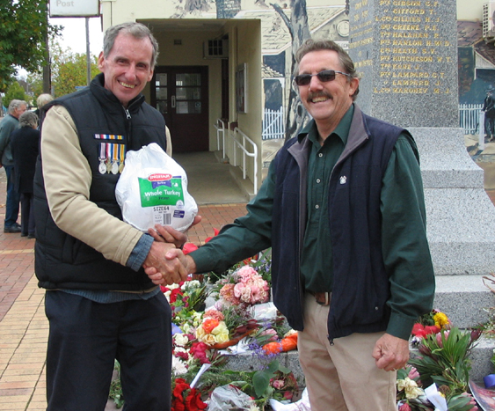
BK receiving the Turkey ‘peace offering’ from Rob McAnally April 15th 2015

.

